Municipal autonomous educational institution "Gymnasium № 87", Saratov
Section: “Foreign languages/Ecology”

How Global Warming Affect
the Climate of Our Planet

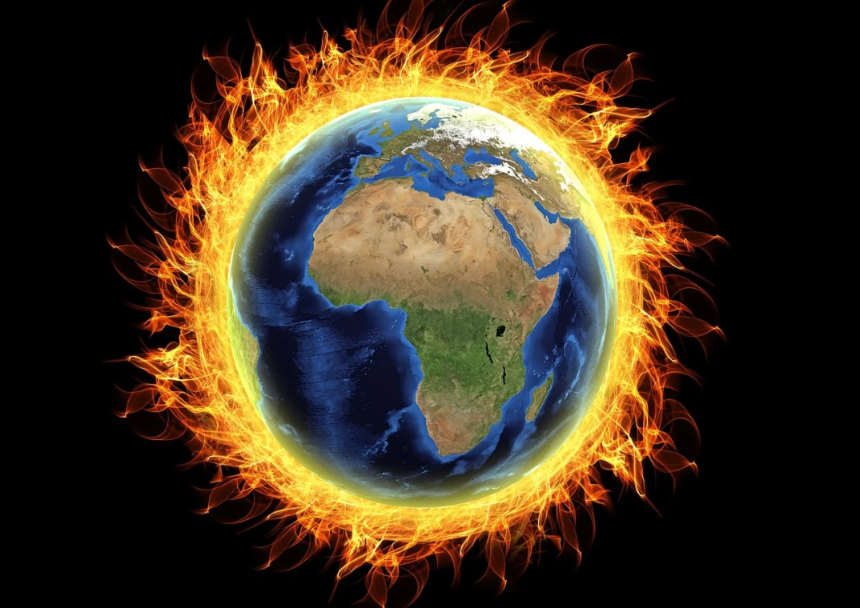

By: Bugrov Dmitry
The student of the 10th grade Supervisor of studies:
Airapetyan Marina Maksimovna

Contents

Introduction 3
Chapter 1. Modern environmental problems 4
Chapter 2. ”The Greenhouse effect” what is it? 5
Chapter 3. Causes of the greenhouse effect 7
Chapter 4. How to minimaze the greenhouse effect? 10
Conclusion. 10
List of references: 12

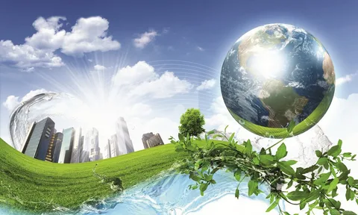

Introduction

Ecology is a factor that determines how high the standard of living and health will be. The problem of the planet's ecology will always be relevant because people want to correct and avoid new mistakes in relation to the nature of our home called Earth. How small and fragile our world is! How beautiful it is! Our planet, fragile and delicate, is a product of the indomitable forces of nature.
Our unique and multifaced planet seems colossal when we cross a field, ascend the mountains, sail across an ocean or fly aboard a plane. But looking at the Earth from the outer space we can realize how small our world is – both we ourselves and our beautiful planet. We love our native lands – our cities, our villages, our steppes, our forests. But what is the whole of our native planet about? We should love our remarkable, our one and only Earth. Global warming is an indicator of the increase in the average ambient temperature over the past century. Its problem is that, since the 1970s, this indicator has been increasing several times faster. The main reason for this lies in the strengthening of human industrial activity. The temperature has increased not only in the water, but also in the air.
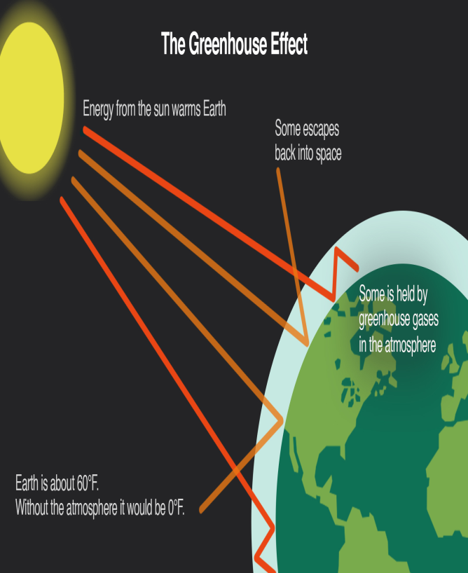 | Changes in the climate could have a significant effect on natural ecosystems, forestry and agriculture. Such impacts would be complex, depending on local climate changes and the eco-system concerned. Climate changes only very slightly over a human lifetime, but can change significantly over centuries. There have been dramatic changes on longer timescales (10,000 years and more) as the earth has entered and emerged from ice ages.

The world is currently in a warm interglacial period, between ice ages. Climate change could also affect many human activities, such as energy production and distribution, transport, urban development, building standards and health care.
You can ignore it, not pay attention to it, but this does not mean that sooner or later you will not face to face the consequences of global warming.
The aim of my report is to ascertain how global warming affect the climate of our planet Earth.
To achieve this aim, the following tasks were defined:
- search and analysis of information about global warming;
- identifying the consequences of global warming;
- make conclusion and give advice on how to prevent an increase in the average temperature.

Chapter 1. Modern environmental problems

Modern environmental problems are problems that have arisen as a result of the active influence of man on the natural processes occurring in nature. Such influence became possible in connection with the development of the scientific and technical potential of mankind, aimed at ensuring the lives of people. At the same time, the existence of the surrounding living and inanimate nature is not taken into account.
Their consequence will be that the biosphere will gradually turn from a natural system into an artificial one. For a person, this means only one thing, that like any ecosystem created by him, it will not be able to exist without a person, without his help and close attention. The ecological problems of our time will become, if they have not become the ecological problems of humanity yet.
The concentration of carbon dioxide in the atmosphere helps determine Earth’s surface temperature. Both CO₂ ”carbon dioxide” and temperature have risen sharply since 1950. International experts in climate change have analyzed air and tea temperature records. They have found that global average temperatures have been rising slowly and unevenly since we have been able to measure them accurately, and that the earth may have warmed by as much as 0.5⁰C over the past century.

Chapter 2. ”The Greenhouse effect” what is it?

A greenhouse is a building made of glass, where you can grow flowers and other plants that need a lot of warmth.
How does it work? The sun shines in through the glass and warms the greenhouse, and the roof and walls keep the heat from getting out.
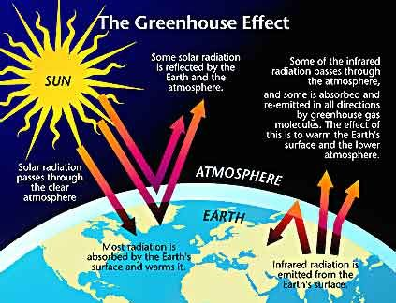 | The Earth is surrounded by a blanket of invisible gases (with names like carbon dioxide) that act just like a greenhouse. The sun shines in, and the blanket of gases traps the heat like a roof, keeping it close to the planet. That’s good – we can’t live without warmth.

The Sun is the Earth's only external source of energy. This energy can reach and warm the Earth because atmosphere is transparent to visible radiation.

The surface temperature of the Earth will reach a steady value when the rate of absorption of the Sun's rays at the surface just balances the rate of heat loss to space by radiation from the Earth.
If the earth’s temperature gets hotter by just a few degrees, it could change the weather all over the planet in big ways. Places that are warm would become too hot to live in, and places that are cold would become warm. The places that grow most of our food could get too hot to grow crops anymore.
A few centuries ago, this environmental problem existed, but it was not so obvious. With the development of technology, the number of sources that provide a greenhouse effect in the atmosphere increases every year. The main result of the greenhouse effect is climate change. As the air temperature increases every year, the waters of the seas and oceans evaporate more intensively. Some scientists predict that in 200 years, such a phenomenon as the "drying up" of the oceans will become noticeable, namely, a significant decrease in the water level. This is one side of the
problem. Another is that rising temperatures lead to the melting of glaciers, which contributes to an increase in the water level of the world's oceans, and leads to flooding of the shores of continents and islands. The increase in the number of streams and flooding of coastal areas indicates that the level of ocean waters is increasing every year. An increase in air temperature leads to the fact that territories that are not sufficiently moistened by atmospheric precipitation become arid and uninhabitable. Crops are dying here, which leads to a food crisis for the population of this area. Also, animals do not find food, because plants die out due to lack of water.
Many people have already become accustomed to weather and climatic conditions throughout their lives. As the air temperature rises due to the greenhouse effect, global warming occurs on the planet. People can't stand high temperatures. For example, if earlier the average summer temperature was +22-+27, then upgrade to +35-+38 it leads to sun and heat stroke, dehydration and problems with the cardiovascular system, and there is a great risk of stroke.
Specialists in abnormal heat give people the following recommendations:
- reduce the number of movements on the street;
- reduce physical activity;
- avoid direct sunlight;
- increase the consumption of simple purified water to 2-3 liters per day;
- cover your head from the sun with a headdress;
- if possible, spend time during the day in a cool room.

Chapter 3. Causes of the greenhouse effect

Ozone is a form of oxygen, which has three atoms instead of the usual two. The ozone layer is the part of the atmosphere where ozone is most concentrated. It lies in the stratosphere, which is between 10 and 50 km above the earth. Up in the sky, above the air we breath, there’s a layer of gas called ozone. It helps us by blocking out rays from the sun that can harm our skin, and by letting the rays that are good for us come through. We’re lucky to have the ozone to protect us!
What’s happening? Now the ozone layer is being damaged by gases that people have made. The gases are called CFCs (chlorofluorocarbons) and halons. They are used in refrigerators, fire extinguishers, air conditioners, plastic foam, and some other things.
Ozone is a greenhouse gas. It is created in the stratosphere by the action of the Sun's ultra-violet radiation and in the troposphere by a chemical reaction with reactive hydrocarbons. Air is the most essential element for all living organisms and yet, most humans play a big role in polluting this essential resource. Air pollution may not be as dangerous in its direct outcome as nuclear or water pollution can be, but in the long term it will have a tremendous effect on the environment and health of its organisms living in. Asthma, cancer, acid rain, and the disability to photosynthesize are only a few causes of air pollution. The atmospheric pollutants with the greatest effect onto the environment are the carbon monoxide, carbon
dioxide, hydrocarbons, sulfur dioxide, nitrogen oxides, dust particles, radioactive isotopes and chlorofluorocarbons.
The major new provision in the Environmental Protection Act is the duty of care, which applies to all those who have responsibility for waste at any stage, from production to disposal.
In recent years, people have become more sensitive towards the environment. Scientists and politicians realize that urgent measures should be taken to keep our planet suitable for living and to preserve for future generations.
There may be at least two courses of action to avoid environmental doom. One would be to stop the industrial development, which is unrealistic. The other is so turn technology to the construction of physiologically and socially healthy environment, which seems, the only path to follow.
People should widely use purifying systems for cleaning, trapping harmful substances, introduce pollution control system, protect and increase greenery and create green zones. These simple, practical measures can improve ecological situation in every city and every country.
The ozone layer surrounds the earth protecting it from the sun's harmful ultraviolet rays, which can cause skin cancer and destroy plant life. The relationship between global warming and ozone depletion is fairly straightforward. When the green house effect absorbs heat and prevents it from returning to the stratosphere, global warming occurs. If this heat does not rise successfully back into the atmosphere, then the automatic result is a decrease in temperature in the stratosphere. These lower temperatures are the main course of ozone depletion, since the ozone layer does not develop well at lower temperatures. If increased ultraviolet light reaches the earth, we can expect more skin cancers and eye cataracts.
Environmentalists and scientists are united in pointing out that, a further 1 per cent drop in the overall ozone layer can cause an increase of skin cancer that may affect up to a million people over one generation.
The fundamental importance of the ozone layer is that it acts as a filter, intercepting most of the sun's radiation, including potentially harmful ultraviolet B rays, which can cause melanoma. An ever-thinning ozone layer could eventually allow a more harmful form of radiation known as ultraviolet C, to hit the Earth. It can penetrate cells in the body and irreparably damage the nucleic acid and proteins, which are the building blocks of life.
Man-made disasters and accidents are examples of global environmental problems from which no one doubts. These incidents are receiving international condemnation. No one can eliminate the consequences that have arisen as a result of the biosphere.

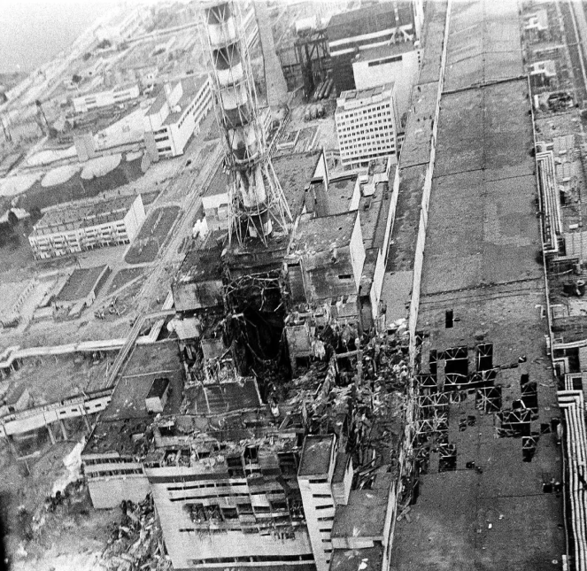 | If the Earth's biosphere is compared to glass, and an accident, such as at the Chernobyl nuclear power plant, with a hole from a stone that got into it, then the cracks that spread from it are consequences that still lead to the unusability of all glass. A person can and should increase security, but cannot eliminate the consequences.

Immediately after the disaster, many animals died, which interacted with highly irradiated objects, for example, the debris of the fourth power unit, which scattered several kilometers from the explosion site, with radioactive dust. Also, a forest area near the Chernobyl nuclear power plant was affected by radiation. It was named "Red Forest" because under the influence of radiation, the needles changed their color to rusty within 30 minutes after the accident. The forest area is 202 square kilometers. After the accident, during decontamination, the affected trees were bulldozed and buried, but even now there is a very high radiation background in some areas. However, a number of scientists note that 30 years after the accident, in the absence of man, the exclusion zone has become a kind of reserve in which rare species of animals live.

Chapter 4. How to minimaze the greenhouse effect?

Knowing how greenhouse gases arise, it is necessary to eliminate the sources of their occurrence in order to stop global warming and other negative consequences of the greenhouse effect. Even one person can change something, and if they are joined by relatives, friends, acquaintances, they will show an example to other people. This is already a much larger number of conscious inhabitants of the planet, who will direct their actions to preserve the environment.
First of all, we need to stop deforestation, plant new trees and shrubs, because they absorb carbon dioxide and produce oxygen. Using electric vehicles will reduce the amount of exhaust gases. In addition, we can change from cars to bicycles, which is more convenient, cheaper and safer for the environment. We are also developing alternative fuels, which, unfortunately, are slowly being introduced into our daily lives. One interesting idea to prevent global warming is to reflect the light that falls on us. In theory, we can increase the reflective properties of the Earth by repainting the roofs of houses in white. We can also cover the roads with limestone. In addition, scientists propose to plant more light crops on our planet. It sounds very interesting, because scientists claim that "brightening" the world around us can significantly cool the city. And in such conditions, perhaps, people will stop using air conditioners, which also produce a large amount of greenhouse gases.

Conclusion

Summing up the results of the study, we can draw the following conclusions. The climate on the planet is changing rapidly. As mentioned above, humanity has reached a point where the consequences of global climate change will be irreversible. They are already endangering human health, food security, and can lead to flooding of coastal cities. In the near future, people will face weather-related disasters that will cause billions of dollars in losses. Global warming is just one of many current environmental problems. There is a need to disseminate knowledge about climate change and what it entails as widely as possible. Create community groups to implement sustainable management practices at the local level. All these measures, if they are used by billions of people every day, will ensure sustainable development and will hardly affect the standard of living of the population.

WHAT CAN WE DO?
- Use bicycles and public transport instead of private cars. Public transport is less polluting than cars.
- Save paper, which also helps save the forests, and use recycled paper as often as possible.
- Eat less meat, particularly red meat from methane-producing cattle.
- Save energy – make sure that the heat, created in power stations, doesn’t just get lost. Even switching off lights helps.
- Help save the forests. Support or join campaigns to save the forests, plant trees yourselves.
- Avoid fast-food packaging if it doesn’t say that it is CFCs-free and try to avoid those blown-foam trays used in supermarkets for meat and fruit. Instead, buy unpackaged food when you can.
- Encourage your families to use fewer paint sprays, de-acres, hairsprays and air fresheners.

Remember, the ozone crisis and the greenhouse effect aren’t somebody else’s problem…they are affecting you right now!

List of references:

1.Динес Л.А., Трофимова Н.А., Крашенникова Я.Ю. Человек и окружающая среда.- Саратов. - Саратовский государственный социально-экономический университет, 2018,- 205с.
2.Данилов В.А., Савинов В.А., Макаров В.З., Чумаченко А.Н. Национальный парк "Хвалынский": ландшафтная характеристика и географическая информационная система.- Саратов.- Издательство Саратовского университета , 2006,- 145с.
3.“National Geographic” 2004
4.“Science in Russia” - №2 2014 p. 42-48
- №6 2012 p. 40-43
- №3 2012 p. 43-52
5.“English” приложение к «Первое сентября», 2014-2018гг
6.Mikhail Rebrov “Save Our Earth” – Mir Publishers Moscow, 2009
7.Robert Allen “How to Save the World” – CorGi Book, 2012
8.Yu. Novikov “Environmental Protection”- Mir Publishers Moscow, 2000

