Муниципальное бюджетное образовательное учреждение
«Средняя общеобразовательная школа №30»

Тема проекта:
Animals in the state symbols of English-speaking countries

Выполнили:
Ученицы 10 «А» класса
Лобанова В.Е. и Бердова Е.С.
Руководитель:
Постоева И.В.

г. Подольск
2021г.
Оглавление

Introduction 3
New Zealand 4
Symbolical animal 4
Appearance 5
Why this is considered a symbol? 6
Australia 7
Symbolical animal 7
Appearance 8
Why this is considered a symbol? 9
The United States of America 10
Symbolical animal 10
Appearance 11
Why this is considered a symbol? 12
Canada 13
Symbolical animal 13
Appearance 14
Why this is considered a symbol? 15
Conclusion 16
List of literature 17

Introduction

Most often, a symbol is an identification mark, a conditional sign of certain phenomena and concepts. People have always treated divotny with respect, applied images of animal on clothes and body. Later, the concept of a totem animal appeared, which was invented by the Indians. Each tribe chose an animal to symbolize it. Over time, the animals were depicted on the official signs of the camp-coats of arms. And now people use animals as cultural symbols to represent their countries and citizens. National symbols evoke a sense of community, create a sense of unity and patriotism. Animal symbols of all countries have a rich history straight from ancient times. Therefore, many countries have their own national animal symbol, and some even have several.

New Zealand
New Zealand is a state located in the southwestern Pacific Ocean on two islands the North Island and the South Island. Speaking of the geological nature of this country New Zealand separated early from the supercontinent Gondwana and thus created a unique ecosystem. Local birds have adapted to the local environment and play the role of animals, but many of them have stopped flying due to the lack of predators.

Symbolical animal
New Zealand has many symbols, but the most famous symbol is a flying bird called the Kiwi. This bird belongs to the category of wingless.

Appearance
Kiwis are birds that can't fly. Wings, of course, are present, but they are poorly developed. This bird has no tail, but it has strong legs with sharp claws. In size, it is about 60 centimeters. It also has a fairly soft plumage that covers the entire body. This bird is endowed with a very good sense of smell, as the nostrils are located at the end of its long beak, and not at the beginning. And the antennae located at the base of the key, the bird uses to touch. Its beak is so strong that it can break through the roof of a car.
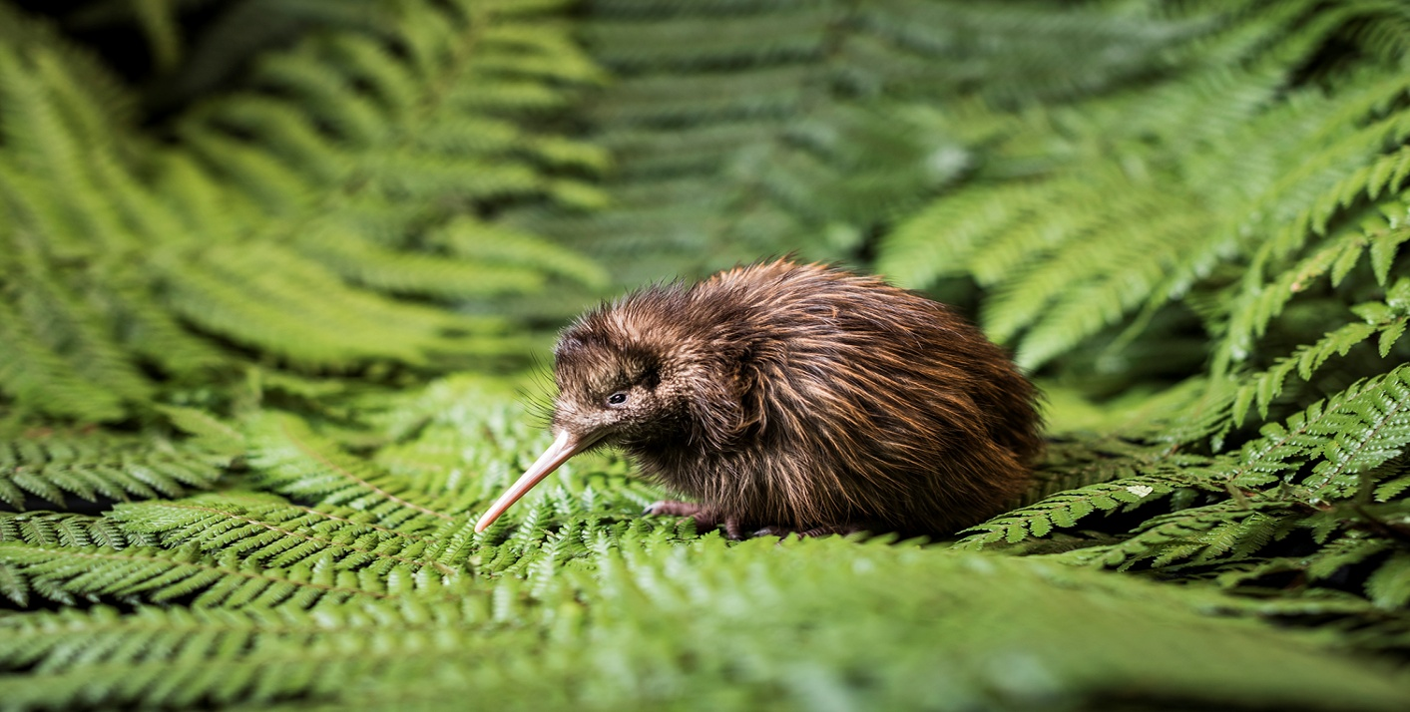
In real life, it is quite difficult to catch them, because they are nocturnal birds. During the day they hide, and after sunset they go out to hunt.

Why this is considered a symbol?
Local residents often call themselves kiwis. They joke that they are so called because they are sleep lovers. And kiwi birds, as we know, are nocturnal birds. Although the kiwi is not official national symbol of New Zealand it is the most recognizable and beloved representative of nature in the country. The image of this bird can be seen on coins, jewelry, souvenirs, as well as on logos and advertising banners. New Zealanders take their symbol very seriously and don't take jokes about it. After all, the kiwi is not just a bird but a whole symbol of the country.
Unfortunately, now kiwis are on the verge of extinction, as Europeans appeared on the territory of New Zealand, and with them dogs, cats, rats and other animals dangerous to birds.

Australia
Australia is the oldest continent washed by the Pacific and Indian Oceans and is the sixth largest country in the world, so the animal world is characterized by a huge number of animals that are not found anywhere else in the world. It is the long-term geographical isolation that has become the main reason for the formation of such a peculiar animal world.

Symbolical animal
The real Australian symbol is the red kangaroo. This remarkable animal lives in the wild zone, and is also the only large marsupial in the world.

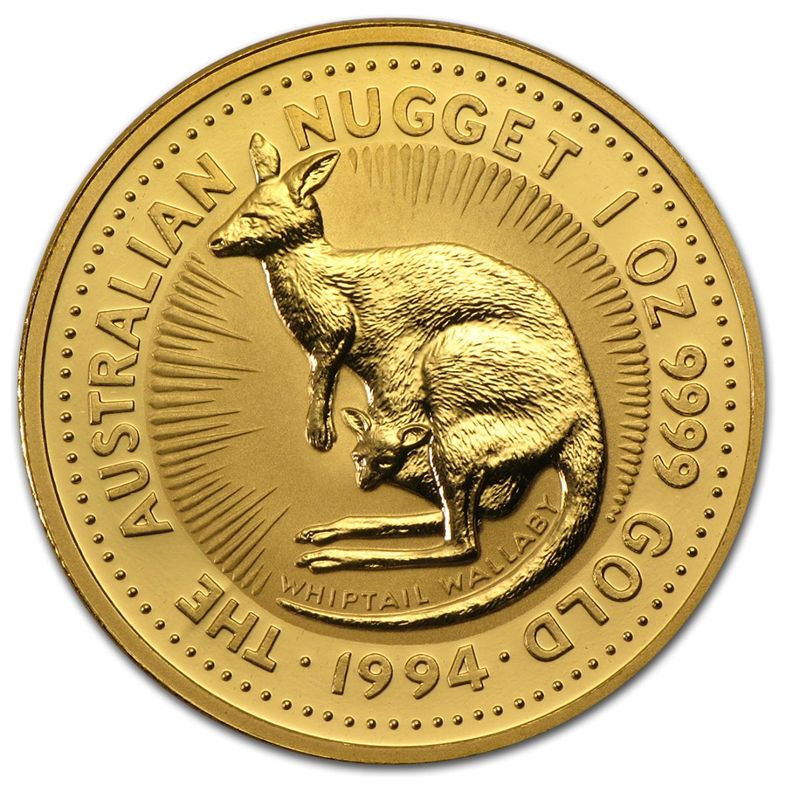

Appearance
The kangaroo has a long massive tail, a thin neck and narrow shoulders. the hind legs are very well developed. when the animal is resting or moving slowly, its mass is distributed on long, narrow feet, which creates the effect of foot-walking, and the forelimbs of the kangaroo, unlike the hind ones, are very small, mobile and somewhat resemble human hands, the hand is short and wide with five identical fingers. The animal is covered with thick hair 2-3 centimeters long. The paint has a bright, rich brick-orange color.
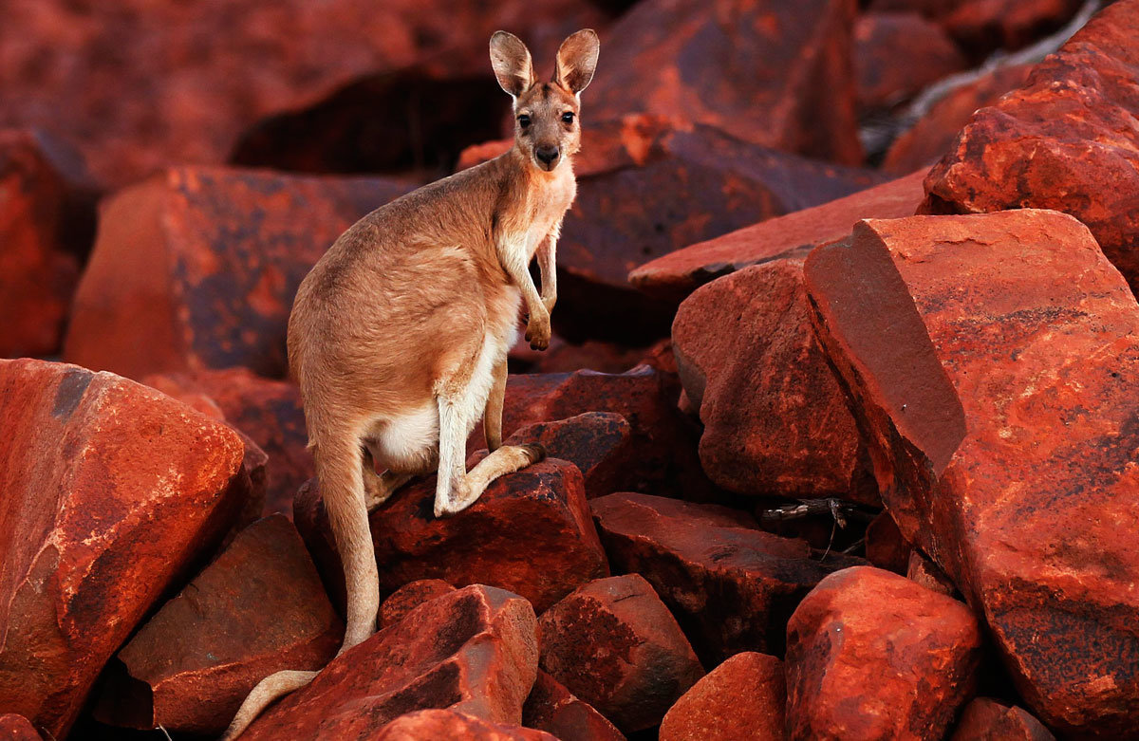
Kangaroo is the only representative of large animals that move with the help of jumps. The normal speed of the red kangaroo is 25 kilometers per hour, but the maximum speed for short distances can reach up to 55 kilometers per hour. It is the need to constantly travel long distances in search of food that has led to the development of a fast and highly efficient method of movement by jumping.

Why this is considered a symbol?
In the late 18th century, British colonists were fascinated by this exotic animal, which was first recorded by the botanist Joseph Banks in 1770, and after the illustrations captured a European audience, the kangaroo became the official symbol of Australia.
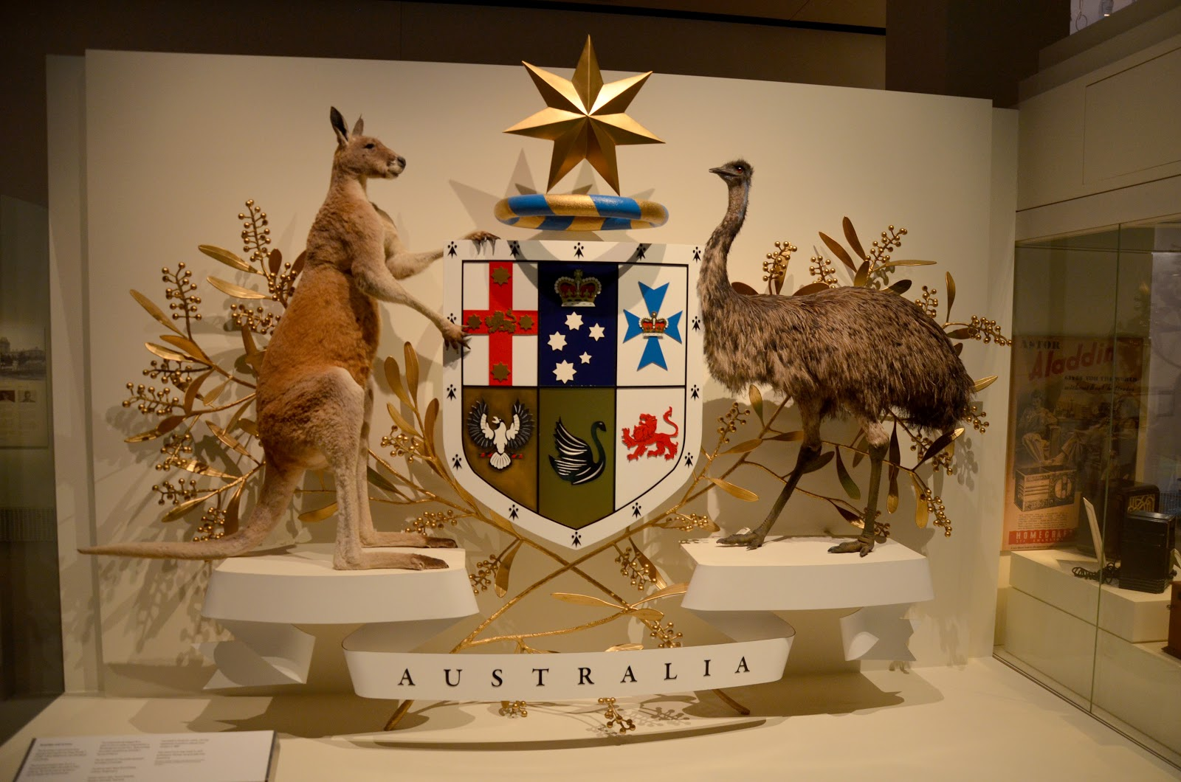
The kangaroo has become the main emblem of Australia and its most enduring symbol. It can be seen on the Australian coat of arms, on the emblems of the Australian Defence Force, as well as on coins and stamps.

Two red kangaroos are included in the coat of arms of Western Australia, the national passenger airliner Qantas uses the image of a galloping kangaroo as an emblem, the State Tourism Administration uses the image of a kangaroo in the logo for instant identification with Australia. A special sign in the form of a golden kangaroo and a green triangle indicates that the product is produced or grown in Australia. Red Kangaroo - Australian Maritime Transport logo, part of the official emblem of the Royal Australian Regiment and the Northern Territory.

The United States of America
America is a part of the world that unites two continents, North and South America. The animal world of America is quite diverse, as the continent itself is located in all climatic zones. It is also helped to be diverse by the abundance of different landscapes: mountains, deserts, swamps, various forests and spacious steppes-all this becomes a home for many animals.

Symbolical animal
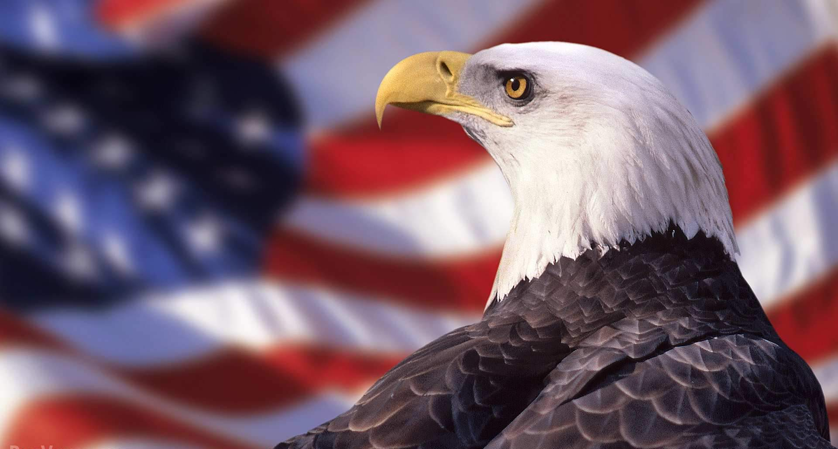
The bald eagle was adopted as the national symbol of America in 1782, when congressmen were discussing what kind of exclusive animal would represent the fauna of great America.

Appearance
The bald eagle is one of the most important large birds. North America. Its size varies from 80 to 120 centimeters, and the weight reaches 6 kilograms. This bird has a dark brown, almost black, color, with a sharp contrast to the white head and tail. Bald eagles have fairly strong nails with long, hooked claws. The hind claw is well developed, which allows you to firmly cling to the prey. So this claw serves as an awl and instantly kills the prey. Bald eagles are famous for their piercing gaze. Their eyes have a bright yellow color, and the growth of on their eyebrows gives the look a great independence. And its wingspan reaches up to 2.3 meters.

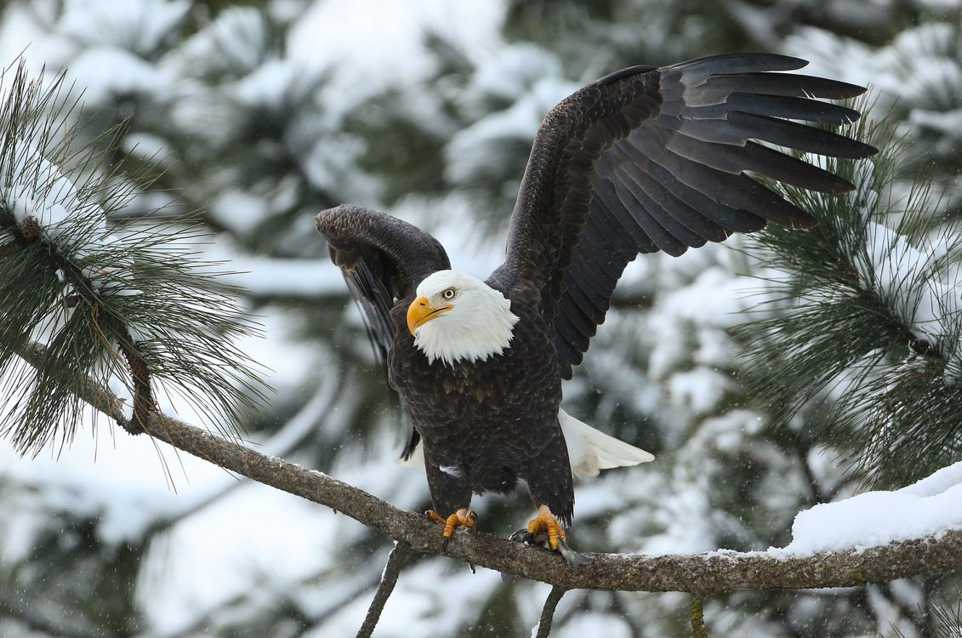
Why this is considered a symbol?
The eagle is an ancient symbol of power and strength. This beautiful bird is endemic to North America, and the locals consider it sacred. On the coat of arms of America, you can see an eagle with two more symbols. In one paw he holds 13 arrows, which represents the power of the state, and in the left paw he holds an olive branch, which represents peace. At the moment, the bald eagle is kept under strict state protection, because it is endangered and listed in the Red Book. The bald eagle was chosen as a national symbol for its beauty, enormous strength, long life, and because it is native to North America.

Canada
Canada is famous for its rich and diverse fauna, and all this is due to its vast territory. The country occupies a huge area, where there are mixed forests, spacious meadows and lakes with clear water, so there is a huge variety of animals.

Symbolical animal
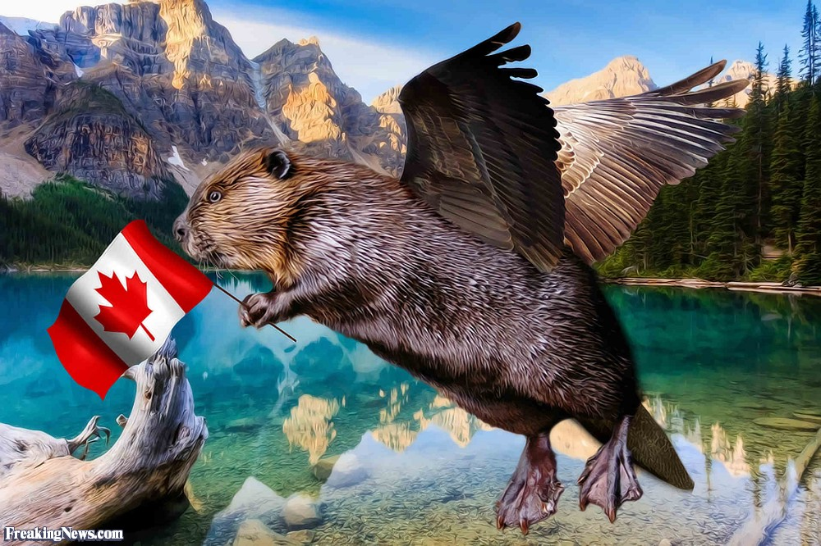
The national symbol of Canada is the Canadian beaver. Published in 1975, the law stated that the image of the beaver became official and now it represents the hard work of the country.

Appearance
The Canadian beaver belongs to the order of rodents and can reach one meter in length. It has a broad paddle-shaped tail, covered with horn plates, between which sparse hair grows. Bob uses his peculiar tail both for milking and for scaring off predators. Also, the Canadian beaver is covered with small scales that are difficult to notice. With this unusual element, the beaver easily swims under water. It is easy to move under water, they are also helped by the hind limbs, which are equipped with special changes, with their help, the animal can gain more speed under water. And with the help of hook-like claws on their paws, beavers deftly dig draw and get food.
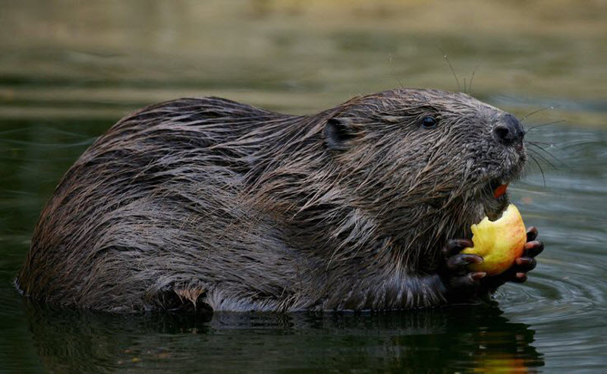

Why this is considered a symbol?
The fur trade was an important factor in the selection of the beaver as the official emblem of Canada. Without the beaver, Canada as we know it would not exist. The fur trade played an important role in the development of the country that would later become Canada. The center of the fur trade was the beaver, whose skins were used to make wool felt hats, robes, and winter coats. The use of the beaver as a symbol is associated with major players in the fur trade, the Hudson's Bay Company, which placed the animal on its coat of arms in 1621. now the beaver is immortalized on the coats of arms of Toronto and Montreal, as well as on five-cent coins.

Conclusion
Thus, considering the examples of national symbols of some countries, it can be noted that each of the countries has its own symbol that reveals their history, embodies their people in its own way gives the population a sense of community and patriotism. Each national symbol is unique and contains its own history, which can go back to ancient times. The animal symbol of the state is not just its emblem or a sign that defines what kind of state it is, something valuable and sacred, embodying the sovereignty and identity of the country. Also, the animal symbol reveals each state on the other hand, you can find out what path the country has taken to choose its national, exclusive symbol.

List of literature
Википедия – свободная энциклопедия [Электронный ресурс]. - https://ru.wikipedia.org. (дата обращения: 08.05.2021)
State symbols USA [Электронный ресурс]. - https://statesymbolsusa.org. (дата обращения: 08.05.2021)
All about Canadian History [Электронный ресурс]. -https://cdnhistorybits.wordpress.com. (дата обращения: 08.05.2021)

