Наименование секции: Иностранные языки

HISTORY AND INFLUENCE OF FASHION SUBCULTURES IN THE UK AND USA IN THE 20-21ST CENTURIES

Проект выполнила:
Кириллова Ольга Александровна
МАОУ Гимназия №10, г. Новосибирск
руководитель проекта: Оганесян Инесса Аркадьевна

г. Новосибирск 2022

Introduction:
The theme of this research work was chosen by me because of the importance of fashion and subcultures in our modern society. Now more than ever we have more freedom in expressing ourselves through clothes. Finding a group of people that share your interests and beliefs (commonly intertwined with your fashion sense) may be one of significant aspects of socialization among teenagers. That’s why I decided to research how fashion subcultures and people affect each other.
Objectives:
- Understand what a subculture is.
- Learn about the history, trendsetters, ideologies, behaviors and the style of the most popular fashion communities in the UK and America in the 20th century.
- Point out the similarities and differences in the modern fashion and fashion of the past.
- Analyze problems that concern the fashion industry
- Survey teenagers about the fashion trends and analyze the answers.
Goal: Come to a conclusion based on research and survey about the 20th century fashion influence on 21st century fashion.
Contents:
- Introduction
- The definition and meaning of subculture
- Subcultures and fashion throughout the 20th century
- «Aesthetics», fashion and its problems throughout the 21st century
- Modern fashion problems, overconsumption, micro-trends
- Survey and statistics
- Conclusion
- Sources
- Attachments
WHAT IS A SUBCULTURE?
A subculture is a social group of people that differs from the majority of people. It is connected by similar beliefs and interests and develops its own ideals, behavior and norms. Subcultures have always existed, but fashion subcultures started to rise and gain popularity only in 1920s. Before that, subcultures didn’t really have a common or widely recognized, defining style. Subcultures usually form to challenge the values of the society or to express interest in a subject. Most often a subculture is started by youth. It can be explained by the natural wish for change and dissatisfaction with social patterns and ideas of the previous generation. In cases when subcultures are formed to express interest in a particular subject or multiple ones their appearance might be explained by the influence of pop culture.
THE 1920S
The first iconic widely known fashion subculture emerged in the west in 1920s and quickly spread to the UK, the members of the subculture were called «flappers»(1). They wanted to challenge Victorian era`s ideals and so did the fashion(2). The women`s silhouette became more rectangular and «boyish» in contrast to restrictive and extravagant ones from the past. The clothing became looser (although corsets were still worn) and showed more arms and legs. The dresses never went above the knee though. The USA women felt empowered because they were given the right to vote in 1920 and the WWI came to a victorious end. That signified the start of big change for humanity and women as well.
Flappers were mostly young women that acted in a certain way. They partied, flirted and argued with men, drank alcohol, smoked, enjoyed jazz music, wore a lot of «shocking» makeup and clothing and overall focused on pleasure and fun in their lives. Flapper girls` style was «outrageous» during that time period because not so long-ago women had to express modesty and intelligence, wear makeup in a way that would not be noticeable and fully cover their whole body with clothes. However now it is one of the most striking and well-known fashion subcultures from the 20th century.

THE 1930S-1950S
Unfortunately, there were not many new famous fashion subcultures in this time period. The United States was experiencing the Great Depression followed by the WWII and the Cold War. People did not have the resources or the time to form new fashion subcultures. Despite all of this, the fashion was still evolving and there were notable trends and changes. The 1930s fashion was glamorous and elegant but compared to the 1920s and the 1940s it was seen as a more boring decade. The 1940s fashion was more colorful, rich in shape and patterns. And by the 1947 the Paris fashion houses had reopened and they started setting new trends in the UK and USA. Elvis Presley(3) and Marilyn Monroe(4) were the celebrity fashion influencers for the time period and Coco Chanel and Christian Dior were the fashion designers that presented new silhouettes and stylish accessories. Coco Chanel`s «The Chanel`s Suit»(5) and Christian Dior`s «New Look»(6) were large trends at the time.

THE 1960-1970S
With the civil rights movement (1954-1968) and the intensification of the Vietnam War (1955-1975) a cultural phenomenon named «counterculture of the 1960s» appeared and spread throughout the Western world. The Counterculture was defined by their disapproval of racial, ethnic and political injustices. As the decade went by and the movement evolved a subculture of hippies(7) appeared. In the UK, hippies prefer to call themselves the Peace Convoy. They travelled from one music festival to another and even started their own – The Stonehenge Free Festival. Both the British hippies and the American hippies were often pacifists, participated in non-violent demonstrations and spoke up against war. Hippies listened to psychedelic music, often used drugs, advocated for love and tolerance.
This subculture`s fashion challenged gendered clothing – both men and women wore jeans or pants, had long hair, wore sandals and lots of accessories. Their style had vagrant feel to it. It was common for men to wear beards and women to use little or no makeup. Hippies chose colorful and unusual clothing and accessories and popularized tie-dyed garments. Clothing inspired by Native American, Latin American, African and Asian cultures were also commonly worn. Hippies` fashion challenged the tight silhouettes of the previous decades. These people rejected consumerism and celebrated self-made extravagant clothes and accessories. They were painting their personal belongings, vehicles and homes with bold colors and psychedelic art.
Soon after the hippies a lot of other subcultures formed around their love for music and art. The most famous ones I researched are goths and punks(8).
The punk subculture was created in the UK by working class people who enjoyed punk rock music and supported the ideas of individual freedom, anti-establishment and do-it-yourself ethic. This subculture was like a tool for youth to speak up about their disapproval of the current political, economical and sociаl situations. They expressed their negative emotions through art. That’s why many British people nowadays can describe theis subculture of the teenage years as more aggressive and toxic compared to the USA punk. Some punks argued that their subculture should not be about fashion, but about ideologies and music. Nevertheless now we all know punk style as one of the most remarkable and outstanding one. Punks had colorful dyed hair, crazy and messy hairstyles like mohawks and spiked hair. The most famous element of the punk fahion are definetely leather jackets. Punks decorated them with metal spikes, buttons, safety pins and whatever else they could find to add on so their jacket would look uniqe. Both men and women wore a lot of dramatic makeup, painted their nails and pierced their ears.
Adored by many memders of the community Vivienne Westwood(9) became the trendsetter for punks. She was loved for her political clothing. She had anti-fascist principles, addressed climate change issues and promoted ethnical fashion(10).
As the punk subculture was gaining popularity a new music genre appeared. Gothic rock is an offshoot of the punk music genre. Yet again a group of people who listened to this music formed their own subculture with their own aesthetic. The gothic subculture(11) began in the UK as well in the late 1970s. Their style and demeanor can be described as «dark, mystic, tragic, creepy and romantic». Goths drew inspiration from gothic literature and from horror films. Their clothes also had Victorian and Edwardian eras motifs. Goths were not less artistic with their style than punks, but they were less political. The goth subculture was all about their feelings, creativity, self-identity and shared mental struggles. Compared to punks goth`s pallet was more monotone. It mostly consisted of dark or black colors. Just like in cases of previous subculture gothic style celebrated gender non-conformity. Both men and women used makeup, painted their nails and wore many accessories.
THE 1980-1990S
As the years went by the USA also was forming various subcultures. With the popilarity of the rock group Nirvana the new grunge subcutlure formed. Nirvana was not the only music group whose lyrics were dark, angst-filled and nihilistic. Other performers caught on and explored themes of emotional isolation, self-doubt, betrayal and freedom. The fashion itself was popularized by the musicians who performed in the same clothes that they wore at home. It was anti-fashion. The trendsetter for this decade was definetly the lead singer of Nirvana. Clothes(12) that members of the grunge subculture wore were messy, ill fitting and had a vintage feel to it. It is because it was common to thrift clothes or to buy them second hand. Like the hippies, grungers were anti-consumerist. That means that the less money you spend on your outfit the «cooler you are». Often grungers wore flannel shirts, knit sweaters, ripped jeans, boots, fingerless gloves and leather jackets.
THE 21ST CENTURY
In the 2000s many subcultures still existed or were brought back. The subculture that really shocked the world at that time was the emo(13) subculture originated in the USA. It seems as though everyone in their mid-twenties now was emo ten years ago. Emo is a rock genre that focuses on emotional deep lyrics and the music is both soft and loud. Emos` behavior and style can seem quire similar to goths at first glimpe, but actually there are differences. Emos are more emotional and focus on angst more. Their style is more casual compared to gothic style but is still «weird». The origins of the emo subculture can be traced to the 80s punk, although back then it was less popular. The peak of popularity happened in the 2000s-2010s. Stereotyped emo was heartbroken, angsty, sensitive and introverted. Emos clothes were colorful but had dark elements. The widely known black-purple color palette is now the symbol of emo subculture, but other color palettes are still acceptable. What is notable is that emos mostly had dark hair, but with dyed strands sometimes with a striped. Actually, stripes and checkerboard pattern were really on trend. As it usually is with subcultures, both emo-girls and emo-boys used piercings, bracelets, gloves, legwarmers, belts, chains, hair accessories and makeup.
THE 2010S-2020S FASHION AND ITS PROBLEMS
In a decade with the rising internet accessibility, we as a society have developed many subcultures, trends and fashion movements. Celebrities always were the trendsetters, but now we see their fashion even more often. And now with the rise of social media anyone can become a celebrity.
An app called TikTok is a platform for creating and watching short videos. It was launched in 2018 and have immediately became popular among youth. You can see all sorts of videos there – entertaining ones, interesting ones and creative ones. The most enjoyed ones are about fashion. People show off their outfits and show where they bought specific items. That happens not only on TikTok, but it is the most influential platform. This creates micro-trends. In the past trends lasted for 3-5 years and now they only last from 1-3 months. Subcultures are not so popular on social media now, instead, they popularized something called «fashion aesthetic» or just «aesthetic» for short. The term refers to a lifestyle or a style of clothing that you create with clothing itself, accessories and different activities. It is mostly about what you wear though. Aesthetics and fashion subcultures are similar for their core idea. It is a group of people dressing and acting similarly. On the other hand, fashion subcultures are more restrictive, permanent and have ideologies and aesthetics are just styles that you can try on. It is important to note that fashion subcultures still exist. For example, punk, grunge, goth and emo are all communities that thrive alone or have great impact on these new fashion aesthetics. We have punk aesthetic, goth aesthetic and grunge aesthetic. They are not to be confused with the subcultures. People who participate in the aesthetic may only enjoy the style, not the ideologies or music, but enjoying everything that the parental subculture has to offer is also valid.
I researched three most popular modern fashion aesthetics among teenagers: cottagecore, e-girl/e-boy, dark academia.
COTTAGECORE
Fashion aesthetics don’t have a particular place of birth, but they gain fame in the Western world and spread across the world by internet. Cottagecore developed throughout 2010s but is loved by youth to this day. The aesthetic centers around an idealized rural lifestyle`s themes: rural clothing, rural interior design, nature, gardening, baking and bonding with animals. Most people who enjoy this trend just go for more cottage style clothing and do no change their hobbies or living place. The style(14) includes blouses, sundresses, long skirts, hats, corsets, overalls and floral prints. Color palette consists of muted brown, green beige and white colors.
E-GIRLS AND E-BOYS
E-girls and e-boys can be viewed as a subculture and as an aesthetic. It is considered to be the evolution of emo and goth subcultures. The terms are derived from «electronic boy» and «electronic girl» because of the association with the internet. Their fashion(15) consists of the same but more modernized elements of emo fashion. Belts, chains, layered clothes and dyed hair are the most remarkable ones.
DARK ACADEMIA
This aesthetic can also be considered a subculture. This trend is heavily based on the preppy fashion and the «old money» style of clothes from 1950s that students wore. Dark academia centers around reading classic literature, studying and appreciating Victorian gothic architecture. Outfits(16) consist of vests, cardigans, shirts, blouses, knit sweaters, plaid trousers and skirts, coats and overall formal study attire.
MICRO-TRENDS, FAST FASHION AND POLLUTION
All these aesthetic come and go and they usually don’t stick for that long. Fortunately, people are not being harassed anymore for wearing something «out of fashion» because we have realized that fashion is recurring. If you wear something thrifted and old – you`re «vintage», if you wear things that are popular right now – you`re «trendy». The problem occurs when there are too much aesthetics and too much fashion items in public`s attention. Some people start being reckless about it and throw away items that they deem «out of fashion». They also practice one-time outfits that are also thrown out or donated to thrift shops after spending only a day or less in it. So to please the consumer corporations must adapt to these micro-trends. That’s how fast fashion appeared. Corporations use faster production, and exploitative manufacturing processes and plastic or unsustainable bad-quality materials. According to statistics, the average USA consumer throws away 37 kilograms of clothes every year. The fashion industry is responsible for 20% of global wastewater. Fast fashion brands are producing twice the amount of clothes today than in 2000s.
People should reconsider their relationship with clothes. We should thrift more, recycle and always ask ourselves before purchase «will I wear this more than once?». Most people cannot afford to buy from brands that sell sustainable and good-quality clothing. So it is not a bad thing to buy from fast fashion brands and expressing yourself through clothes. However, we have to realize that being conscious about our consumerism is important.
CONCLUSION
Based on my research of history and influence of fashion subcultures in the UK and USA in the 20-21st centuries and the survey I conducted I can definitely say that fashion is an essential part of our society. Through fashion people can express their creativity, disapproval of injustices and find like-minded people. Nevertheless there are always two sides to one coin. Fast fashion and micro-trends seem like the appropriate concepts that come to our modern fast-paced lives. We need to learn how to slow down and to contemplate and revive beauty, learn how to make it accessible for people of all sizes, genders, races, financial statuses and ages. With fashion and subcultures we can see the reflection of society in that time period and these things can never really leave us. To this day we borrow items or designs from the past and reinvent them. All these subcultures and aesthetics create incredible supporting communities for artistic brave people to form new ideas and challenge hostile social norms. It is possible to participate in these fun activities and be thoughtful about the way we consume.
Источники:
https://en.wikipedia.org/wiki/Flapper
https://en.wikipedia.org/wiki/History_of_modern_Western_subcultures
https://www.britannica.com/topic/hippie
https://en.wikipedia.org/wiki/Punk_subculture
https://fashionhistory.fitnyc.edu/
https://goodonyou.eco/micro-trends/
https://www.belletag.com/fashion/style-guide/fashion-aesthetic-types
https://www.stylist.co.uk/fashion/tiktok-fast-fashion-trends/614192
https://earth.org/fast-fashion-pollution-and-climate-change/
https://en.wikipedia.org/wiki/E-girls_and_e-boys
https://en.wikipedia.org/wiki/Cottagecore
https://en.wikipedia.org/wiki/Dark_academia
https://www.marieclaire.co.uk/fashion/1950s-fashion-icons-fifties-style-moments-in-pictures-81397
Приложение 1
THE SURVEY AND ANALYSIS
I conducted a survey among teenagers about fashion and its influence.
1. Do you consider yourself fashionable and/or do you love fashion?
Statistics: 63% - Yes; 37% - No
2. Which of these fashion subcultures/trends from the 20th century are you familiar with?
- Flapper (the 1920s)
- Punk (the 1970s)
- Grunge (the 1980s)
- Bohemian (the 1970s)
- Hippie (the 1960s)
- Hip hop (the 1970s)
- Goth (the 1970s)
- Metalheads (the 1970s)
Statistics: The most recognized fashion subcultures are punk, goth and hippies. The least recognized ones are bohemian and flapper subcultures.
3. Which of these subcultures/trends do you enjoy/consider yourself a part of?
- Flapper (the 1920s)
- Punk (the 1970s)
- Grunge (the 1980s)
- Bohemian (the 1970s)
- Hippie (the 1960s)
- Hip hop (the 1970s)
- Goth (the 1970s)
- Metalheads (the 1970s)
Statistics: The majority of teens do not enjoy/consider themselves a part of these subcultures. However some teens stated that they enjoy/consider themselves a part of punk and grunge subcultures.
4. Do you think these fashion subcultures influenced our modern fashion trends?
Statistics:
- Yes, I thinks so – 80%;
- No, I don’t think so – 10%;
- I don`t know/don`t have an opinion – 10%
5. Which of these modern fashion trends/aesthetics are you familiar with?
- Cottagecore
- E-girl/E-boy
- Emo
- Hipster
- Dark academia
Statistics: approximately the same amount of people recognizes all of these trends with the most recognizable one being emo.
6. Which of these fashion trends/aesthetics do you enjoy/consider yourself a part of?
- Cottagecore
- E-girl/E-boy
- Emo
- Hipster
- Dark academia
Statistics: most teenagers stated that they do not enjoy/consider themselves a part of these fashion trends/aesthetics. Yet a big part of teenagers also has stated that they enjoy/consider themselves a part of Dark academia aesthetic.
Приложение 2
1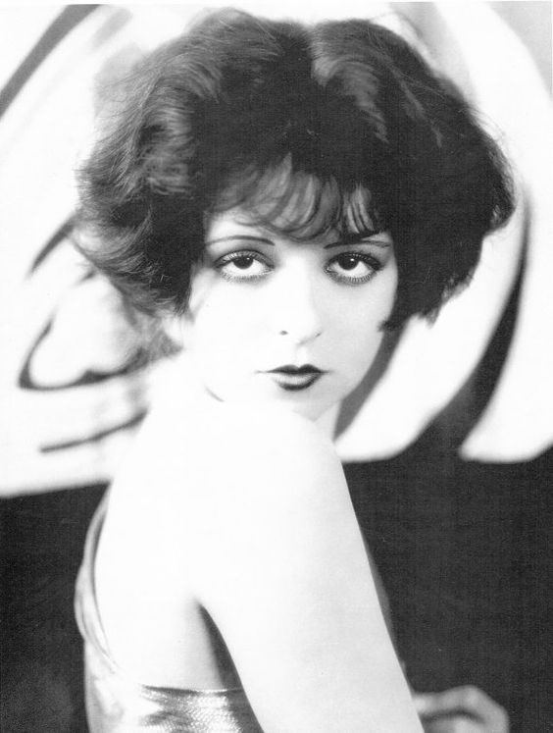 | 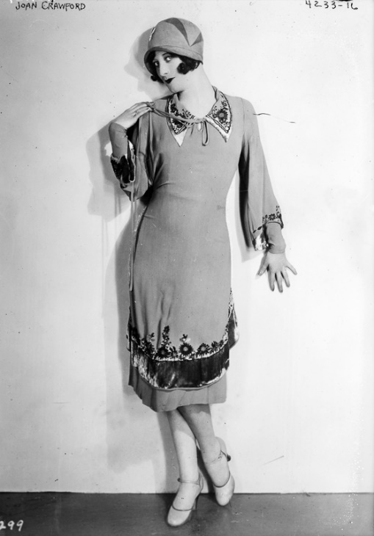 2
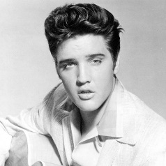 3 | 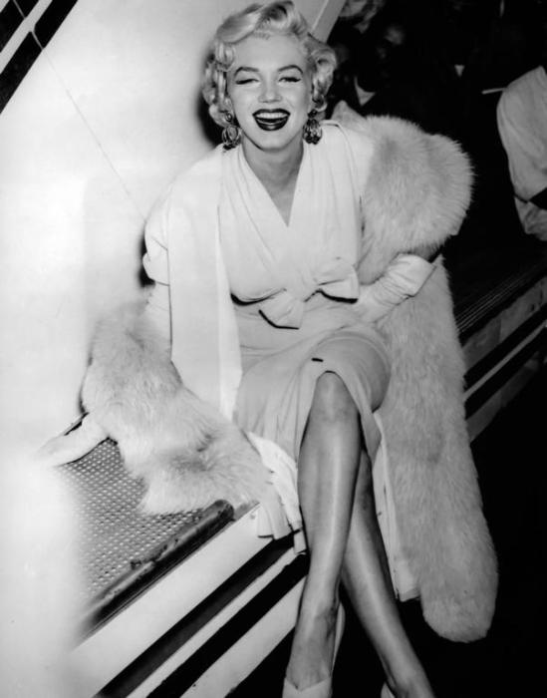 4
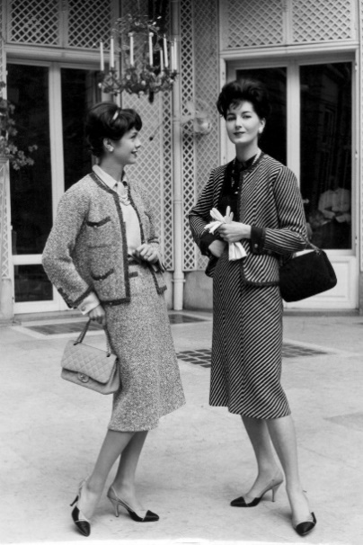5 | 6 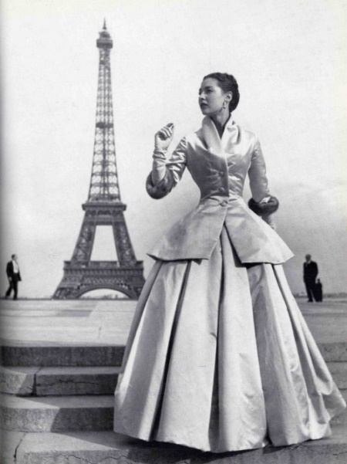
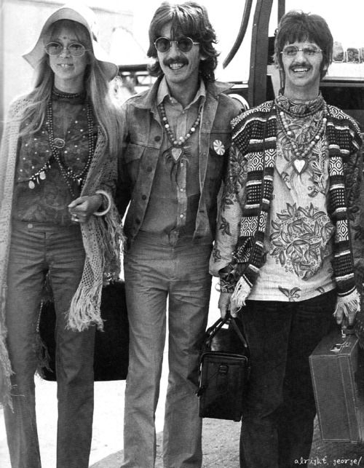 7 | 8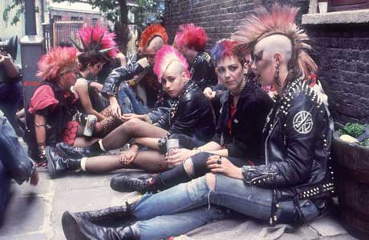
9 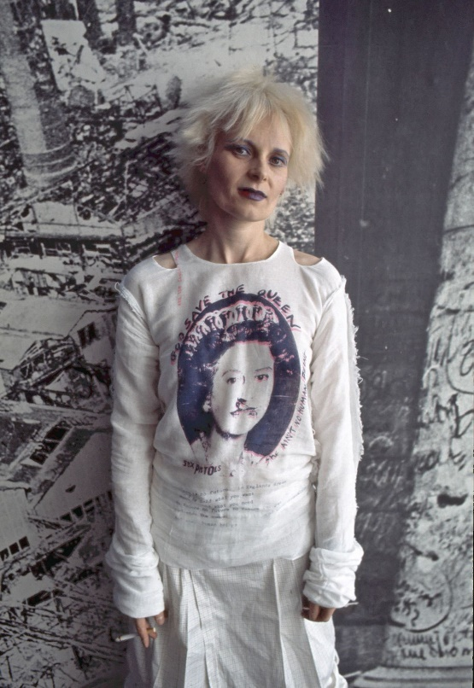 | 10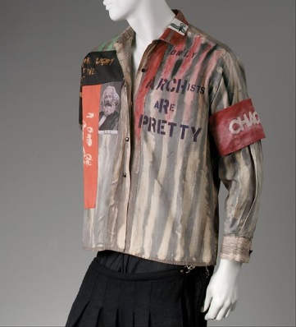
11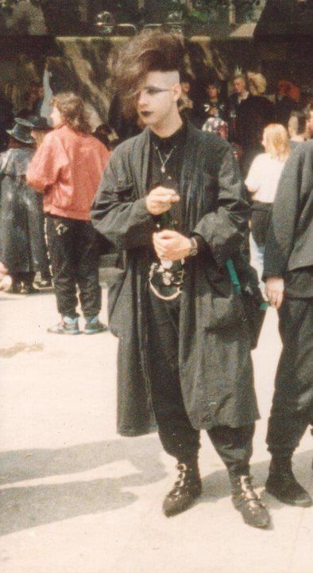 | 12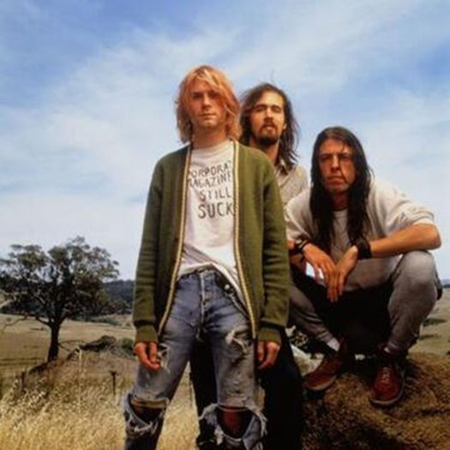
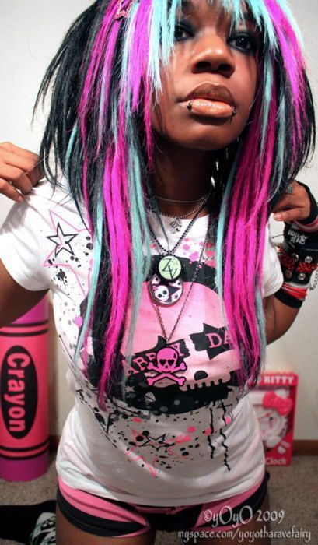 13 | 14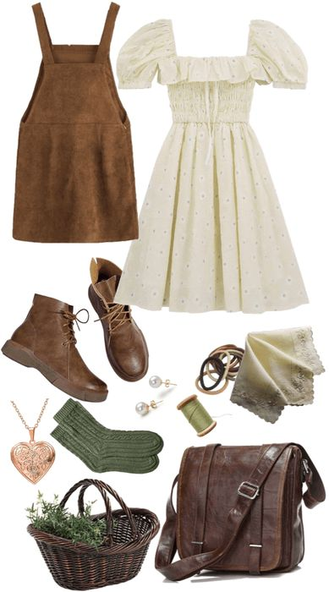
15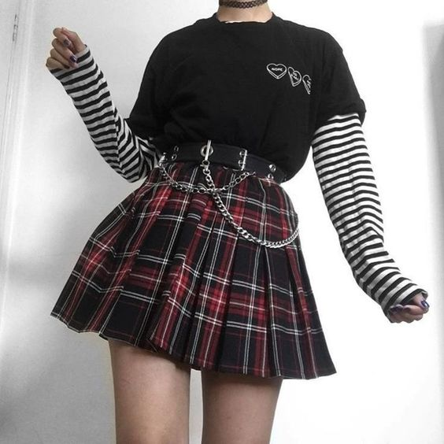 | 16