Hobby in our life
English research work

Student: Karimova K. A.
From 7a form
Gymnasium № 9
named after Kinzi Arslanov
Teacher of English language: Akhmerova R.I.

Meleuz – 2023

Contents
Introduction ………………………………………………………………………. 3
I. The Theoretical Part.
1. The history of a hobby …………………………………………………………. 4
2. Hobby in our life ……………………………………………………………......6
2.1 Types of hobbies ………………………………………………………………8
2.3 Hobbies of famous people ……………………………………………………11
2.4 My hobbies ………………………………………………………………….. 13
II. The Practical Part.
3. Analysis of survey results ……………………………………………………. 15
Conclusion ……………………………………………………………………...16
List of references …………………………………………………………………17
Appendix 1 ……………………………………………………………………….18
Appendix 2 ……………………………………………………………………….19

Introduction
What is a hobby? According to Macmillan dictionary, a hobby is something that you enjoy doing when you are not working. From Wikipedia, the free encyclopedia, hobby is considered to be a regular activity that is done for enjoyment, typically during one’s leisure time, not professionally and not for pay. Hobbies include collecting themed items and objects, engaging in creative and artistic pursuits, playing sports, or pursuing other amusements.
Nowadays it’s hard to name all the activities entertainment and hobbies practiced by people in their free time. But why hobbies are so popular? Is it necessary for everyone to have a hobby?
The aim of my research work is to study the advantages of having a hobby and to share with my hobbies.
The main tasks of research are:
- to study the history of hobbies;
- to define the types of hobbies;
- to consider hobbies of famous people;
- to conduct a questioning among the students and find out the most popular hobbies in my school.
The subject of the research work is a hobby.
The hypothesis: My hobbies help to gain additional knowledge and even find new friends.
To solve the main tasks the following methods were used: the theoretical (the analysis of resources of the Internet and some articles on the topic), empirical (observation), sociological (interview, questionnaire) and statistical methods of data processing. Collecting information about the history and variety of hobbies will enrich the knowledge of the subject.

1. The history of a hobby
In the 16th century, the term “hobyn” had the meaning of “small horse and pony”. The term “hobby horse” was documented in a 1557. The item, originally called a “Tourney Horse”, was made of a wooden or basketwork frame with an artificial tail and head. It was designed for a child to mimic riding a real horse. By 1816 the derivative, “hobby”, was introduced into the vocabulary of a number of English people. Over the course of subsequent centuries, the term came to be associated with recreation and leisure. In the 17th century, the term was used in a pejorative sense by suggesting that a hobby was a childish pursuit, however, in the 18th century with more industrial society and more leisure time, hobbies took on greater respectability.
Hobbies were originally described as pursuits that others thought somewhat childish or trivial. However, as early as 1676 Sir Matthew Hale, in Contemplations Moral and Divine, wrote, “Almost every person hath some hobby horse or other wherein he prides himself.” He was acknowledging that a “hobby horse” produces a legitimate sense of pride. By the mid of 18th century there was a flourishing of hobbies as working people had more regular hours of work and greater leisure time. They spent more time to pursue interests that brought them satisfaction.
During the 20th century, the term hobby suggested activities, such as stamp collecting, embroidery, knitting, painting, woodwork, and photography. Typically, the description did not include activities like listening to music, watching television, or reading. These latter activities bring pleasure, but lack the sense of achievement usually associated with a hobby. They are usually not structured, organised pursuits, as most hobbies are. The pleasure of a hobby is usually associated with making something of value or achieving something of value.
Hobbies change with time. In the 21st century, the video game industry is a very large hobby involving millions of kids and adults in various forms of ‘play’. Stamp collecting declined along with the importance of the postal system. Woodwork and knitting declined as hobbies, because manufactured goods provide cheap alternatives for handmade goods. Through the internet, an online community has become a hobby for many people; sharing advice, information and support, and in some cases, allowing a traditional hobby, such as collecting, to flourish and support trading in a new environment.
Hobbyists are a part of a wider group of people engaged in leisure pursuits. The terms amateur and hobbyist are often used interchangeably. Stebbins has a framework which distinguishes the terms. He describes serious leisure as undertaken by amateurs, hobbyists and volunteers. Hobbyists engage in five broad types of activity: collecting, making and tinkering (like embroidery and car restoration), activity participation (like fishing and singing), sports and games, and liberal arts hobbies (like languages, cuisine, literature).
Children have been an important group of hobbyists because they are enthusiastic for collecting, making and exploring; in addition to this they have the leisure time that allows them to pursue those hobbies. The growth in hobbies occurred during industrialisation which gave workers set time for leisure. During the Depression there was an increase in the participation in hobbies because the unemployed had the time and a desire to be purposefully occupied. Hobbies are often pursued with an increased interest by retired people because they have the time and seek the intellectual and physical stimulation a hobby provides.

2. Hobby in our life
A hobby is something that people like to do when they are not busy with their usual work and have some free time. It is something done entirely for pleasure. Hobbies differ like tastes. If you have chosen a hobby according to your character so you are lucky because your life becomes more interesting.
Having a hobby that we enjoy brings us joy and enriches our lives. It gives us something fun to do during our leisure time and affords us the opportunity to learn new skills.
There are many reasons why all of us should have at least one hobby, but here are the main advantages:
- It makes you more interesting. People who have hobbies have experiences and stories that they can share with others. They also have specialized knowledge that they can teach to anyone who also has an interest in the same topics as they do.
- It helps to relieve stress by keeping you engaged in something you enjoy. Hobbies give you a way to take your mind off the stresses of everyday life.
- Hobbies help you become more patient. In order to develop a new hobby, you have to learn how to do something that is brand new to you. The odds are there will be a learning curve, and you will need to be patient in order to build your skills.
- Having a hobby can help your social life and create a bond with others. A hobby is something that you can frequently enjoy with other people.
- It increases your confidence and self-esteem. The odds are that if you really enjoy an activity, you are usually pretty good at it. Any activity that you can excel in is an opportunity for you to build your confidence and develop pride in your accomplishments.
- It helps you develop new skills. A hobby that you really dedicate your time to will lead you to build new skills. As you spend more time at your hobby you will become better and better at it.
- It increases your knowledge. Along with building new skills, you will also gain new knowledge through the development of your hobby.
- It enriches your life and gives you a different perspective on things. No matter what type of hobby you choose, you will definitely be exposed to new ideas.
- It helps you to prevent bad habits and wasting time. If you have good hobbies to fill up your free time, then you will be less likely to spend that time on wasteful or negative activities.

2.1 Types of hobbies
There are thousands types of hobbies in the world. Hobbies are a diverse set of activities and it is difficult to categorize them in a logical manner. Stebbins developed the following categorization of hobbies.
Collecting
Collecting includes seeking, locating, acquiring, organizing, cataloging, displaying and storing. Collecting is appealing to many people due to their interest in a particular subject and a desire to categorise and make order out of complexity. Collecting is an ancient hobby, with the list of coin collectors showing Caesar Augustus as one. Sometimes collectors have turned their hobby into a business, becoming commercial dealers that trade in the items being collected.
You can collect everything as you want from candy wrappers to antique things (coins, stamps, clocks and watches, models, pictures, CD disks, posters, insects, books, pens, games, toys). The creative hobby is a very popular type of hobby because any creative activity develops one’s imagination, talents, patience, and fantasy.
Making
Making includes working on self-motivated projects for fulfillment. These projects may be progressive, irregular tasks performed over a long period of time. Making hobbies include higher-end projects, such as building or restoring a car or building a computer from individual parts.
Scale modeling is making a replica of a real-life object in a smaller scale and dates back to prehistoric times with small clay “dolls” and other children's toys that have been found near known populated areas. The Persians, Greeks, and Romans took the form to a greater depth during their years of domination of the Western World, using scale replicas of enemy fortifications, coastal defense lines, and other geographic fixtures to plan battles.
At the turn of the Industrial Age and through the 1920s, some families could afford things such as electric trains, wind-up toys (typically boats or cars) and the increasingly valuable tin toy soldiers. Scale modeling as we know it today became popular shortly after World War II. Before 1946, children as well as adults were content in carving and shaping wooden replicas from block wood kits.
People of all ages began assembling replicas in varying scales. Superheroes, aeroplanes, boats, cars, tanks, artillery, and even figures of soldiers became quite popular subjects to build, paint and display. Although almost any subject can be found in almost any scale, there are common scales for such miniatures which remain constant today.
Model engineering refers to building functioning machinery in metal, such as internal combustion motors and live steam models or locomotives. This is a demanding hobby that requires a multitude of large and expensive tools, such as lathes and mills. This hobby originated in the United Kingdom in the late 19th century, later spreading and flourishing in the mid-20th century. Due to the expense and space required, it is becoming rare.
3D Printing is a relatively new technology and already a major hobby as the cost of printers has fallen sharply. It is a good example of how hobbyists quickly engage with new technologies, communicate with one another and become producers related to their former hobby. 3D modeling is the process of making mathematical representations of three dimensional items and is an aspect of 3D printing.
Dressmaking has been a major hobby up until the late 20th century, in order to make cheap clothes, but also as a creative design and craft challenge. It has been reduced by the low cost of manufactured clothes.
Cooking is for some people an interest, a hobby, a challenge and a source of significant satisfaction. For many other people it is a job, a chore, a duty, like cleaning. In the early 21st century the importance of cooking as a hobby was demonstrated by the high popularity of competitive television cooking programs.
Activity participation
Active types of hobby is a hobby connected with extreme, sport and rest (hockey, volleyball, basketball, skiing, swimming, fencing, diving, parkour, yoga, mountaineering, canoeing, riding, paintball). The useful hobby is a wide-spread hobby which over time can become a source of income (gardening, hunting, knitting, sewing, fishing, learning foreign languages). Visiting interesting places helps to learn the culture of different countries, to visit a lot of interesting and historical places (reading, theatre, cinema, photography, travelling).
One large subset of outdoor pursuits is gardening. Although a garden typically is located on the land near a residence, it may also be located on a roof, in an atrium, on a balcony, in a windowbox, or on a patio or vivarium. Gardening also takes place in non-residential green areas, such as parks, public or semi-public gardens (botanical gardens or zoological gardens), amusement and theme parks, along transportation corridors, and around tourist attractions and hotels. In these situations, a staff of gardeners or groundskeepers maintains the gardens.
The gardening will provide a great enjoyment for everyone. It was nice to see the flowers in the garden. There are different types of gardening are there. They are indoor gardening, outdoor gardening, water gardening, container gardening. The indoor gardening is that growing plants inside the house or the building. Nowadays terrace gardening gets an important role in the world. The terrace gardening is good because it will rectify the lack of place for the gardening. The indoor gardening will helps to conditioning the air and temperature inside the house. The outdoor gardening is that growing the plants outside house. The water gardening is other type that is the plant growing in the water. The container gardening is one that growing the plants inside the container above the ground. The gardening has financial benefit. Because by growing the plants for the business will increase the chance of getting income. There are some flowers that have high cost in the market.
Sports and games
Stebbins distinguishes an amateur sports person and a hobbyist by suggesting a hobbyist plays in less formal sports, or games that are rule bound and have no professional equivalent. While an amateur sports individual plays a sport with a professional equivalent, such as football or tennis. Amateur sport may range from informal play to highly competitive practice, such as deck tennis or long distance trekking.
2.3 Hobbies of famous people
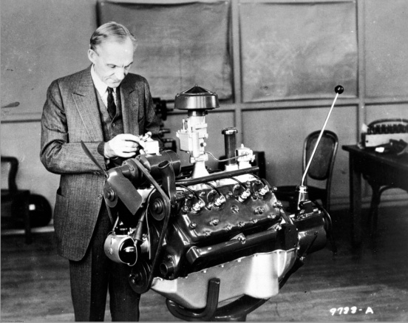
There is something really unusual about hobbies and interests. They vary from person distinguishing one personality from the other. Great and famous people left a lot of discoveries and works of art. For example, such as Henry Ford. As a child, machinery and mechanics were his hobby, he went to collect the engines, he drew designs of machines. And it is not a great time for it has grown into his work. If a child Henry did not like machines, would now might not be the legendary brand cars.
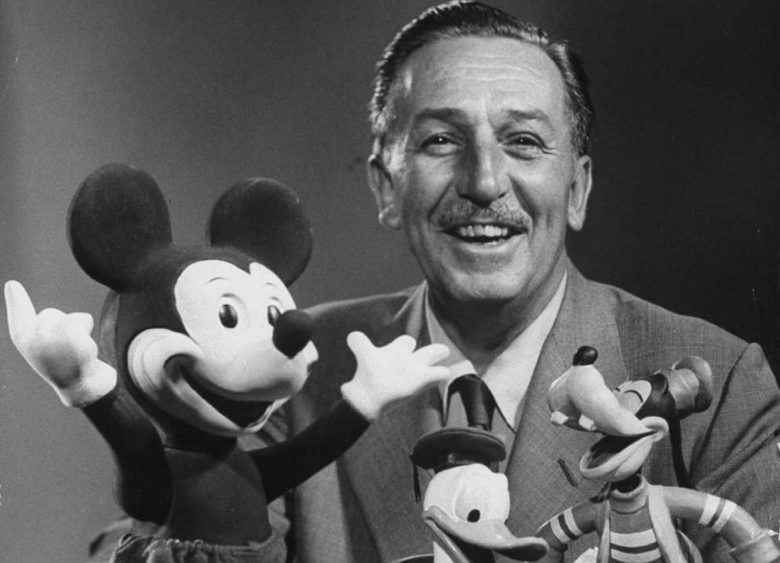
Walt Disney, who just loved trains and each cartoon and amusement park is complete without a locomotive. Perhaps this transport caused Walt to create cartoons!

Joan Rowling - British writer, became well-known due to a series of novels about Harry Potter, did not take literary career in earnest. She began writing stories since childhood, but never thought she would be a famous author. Her hobby has made her one of the most famous and recognizable modern writer.

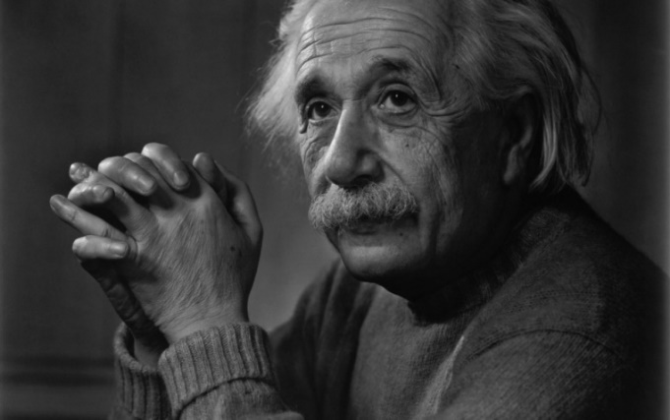
Albert Einstein was able to conquer the philharmonic halls. Scientist mother was a pianist, so a love of music was in his blood. With five years he was engaged in playing the violin and was in love with the music of Mozart. Violin, Einstein began to learn in childhood. At first, he took these lessons as a boring obligation, but once heard a Mozart sonata, who conquered it with his grace and emotion.
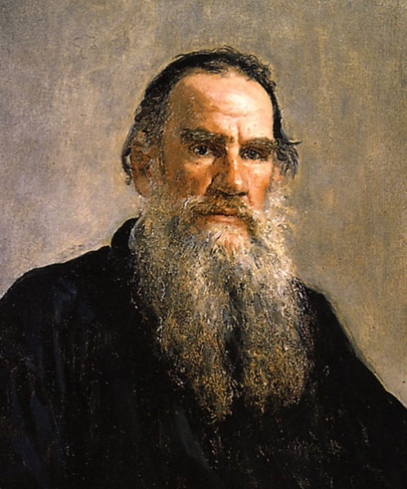
Tolstoy is the great writer was musically gifted. Reading the works of Tolstoy, we see how the music organically enters the world of his characters. The most favorite composer Leo Tolstoy was Chopin. Chopin’s music was extremely close to Tolstoy.
Leonardo da Vinci was a very talented musician. Generally Leonardo da Vinci took up so many things, art and science, and often throwing something in the middle. Such was the case with many of his paintings and frescos, with exercises geometry and other sciences. Also, the music - it was enough for long: just long enough to invent and make a lyre new design - in the form of a horse’s skull. Leonardo da Vinci created a silver lyre in the shape of a horse head.
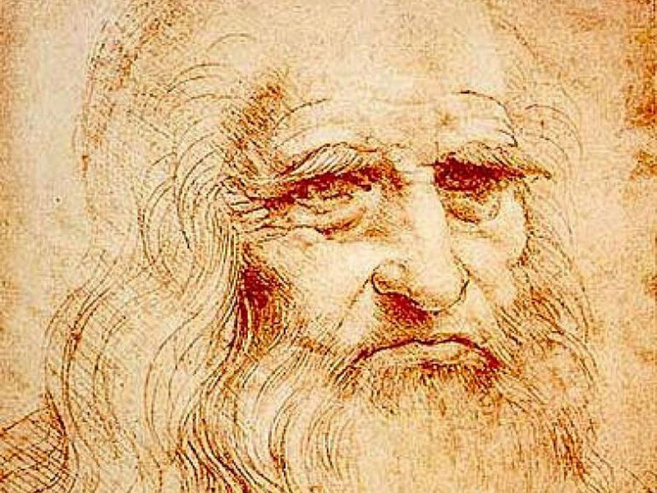

2.4 My hobbies
My name is Karina and I’m having many different skills. Hobbies make my life more colorful and they keep me occupied in my leisure time. Moreover, I believe hobbies help us both to relax and to develop. That is why I have so many hobbies.
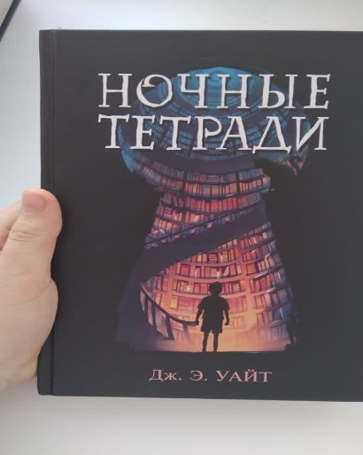
One of my hobby is reading books. I prefer to buy books rather than go to the library. I can spend many hours on reading books so I call myself a bookworm. I’m crazy about fantasy. My favourite writers are Gagloev E. and Jake White. Their works are really exciting. I’m a big fan of movie about Harry Potter and I hope to read all its series of novels.
I’m also fond of singing. Music has an impact on all aspects of development of the person and of human life. I have my passion for music due to my father, he can play the drums. I have been in school choir for 5 years.
Another my passion is drawing. I like drawing beautiful flowers. My hobby makes me observe the world around me every minute of my life. In addition, it helps me to calm down and brings a real satisfaction. I feel happy and never get bored with my hobby. I try to show all my devotion, imagination and creativity in my works.
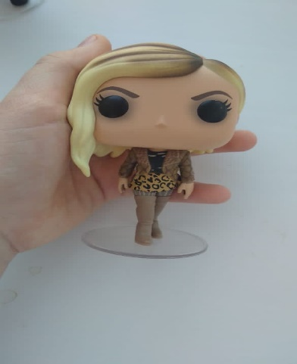
Almost everyone collects something at some period of life: stamps, coins, matchboxes, books, records, postcards, toys, watches. Some collections have no real value. Others become so large and so valuable that they are in museums and galleries. Many world-famous collections started in a small way with one or two items. As for me, I have a wonderful collection of vinyl figures or dolls “Funko”.
Funko Inc. is an American company that manufactures licensed pop culture collectibles, best known for its licensed vinyl figurines and bobbleheads. In addition, the company produces licensed plush, action figures, and electronic items such as USB drives, lamps, and headphones. Founded in 1998 by Mike and Claudia Becker, Funko was originally conceived as a small project to create various low-tech, nostalgia-themed toys. The company’s first manufactured bobblehead was of the well-known restaurant advertising icon, the Big Boy mascot. Sold in 2005, Funko, LLC, is now headed by CEO Brian Mariotti. Since then, the company has increased the scope of its toy lines and signed licensing deals with major companies.
I have met Funko in Moscow. However, they are not for children because the figures are vinyl and fragile. I’ve got just several figures because of their high price and limited selling. But I’m very proud of my collection.
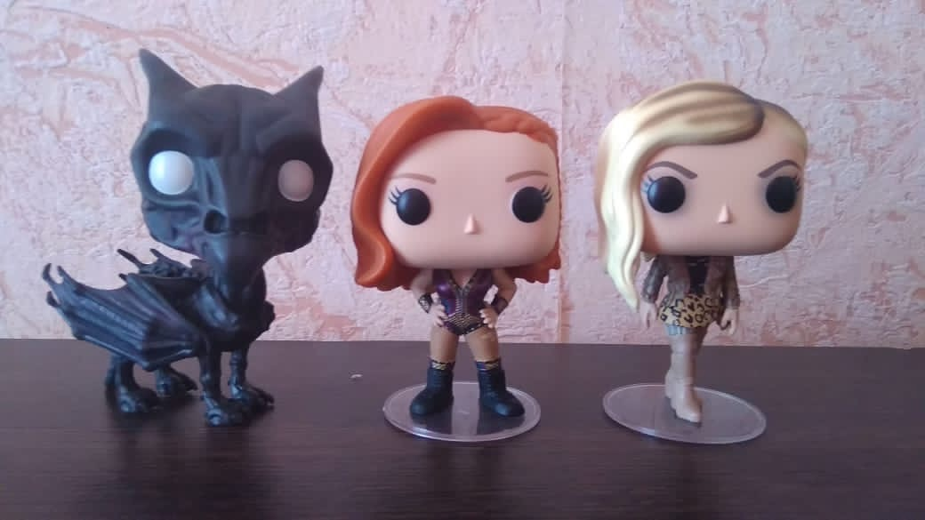
As you see, I have so many interesting things to do. Moreover, I’m trying to find my sense of life through my hobbies.

II. The Practical Part
3. Analysis of survey results
In order to know the opinion of students about hobbies, I’ve conducted a survey. The questionnaire included two questions:
1. What hobbies do you have?
2. Why do you like your hobby?
165 students of MOBU Bashkirskaya gymnasium № 9 named after Kinzi Arslanov took part in the survey. The students from 8 to 16 years old responded to the questions. The results of this questionnaire showed that: 28.7% of students choose sport as their hobby; 26.6% of students like drawing; 15.1% of students are fond of computer and phone games most of the time; 13.3% of them choose reading; 9.7% of students enjoy singing and 6.6% of them choose dancing.
The main reasons of having their hobbies are:
- It’s fun, cool, fascinating, exciting
- I like it
- It helps me to calm down, relax
- I can feel free, express my emotions
- I’m inspired by it
- I like performing on a stage
- It develops and builds my character
- It cheers me up
- I like to win; I want to be a sportsman in the future
The results are presented in the diagrams:
Picture 1. Popular hobbies in my school (see Appendix 1)
Picture 2. Popular sport in my school (see Appendix 2)
Based on these results we can conclude that most of the students are interested in sport.

Conclusion
During the research work “Hobby in our life” we have analyzed the theoretical part (the history and different types of hobbies) and studied hobbies of famous people and our students.
The best way to cultivate a new hobby is to try something new. The world is full of wonderful, exciting activities that we can explore and adopt as our own. Of course, all of us are unique and, therefore, our interests and hobbies vary. However, once we find a hobby that we truly enjoy and are passionate about, we become hooked. It becomes part of our lives and captivates us in a very personal way.
There are many reasons why all of us should have at least one hobby, but here are the main advantages:
- hobbies offer a new challenge;
- it unites you with others;
- hobbies provide an outlet for stress;
- it has physical health benefits;
- it allows you to explore yourself and your talents;
- hobbies prevent you from wasting time and creating bad habits;
- hobbies help you become more patient;
- hobbies make you more interesting.

List of references
1. Macmillan English Dictionary for advanced learners, Macmillan Publishers Limited, 2006 - p. 681
1. https://en.wikipedia.org/wiki/Funko
2. https://en.wikipedia.org/wiki/Hobby
3. https://www.positivelypresent.com/2013/06/benefits-of-having-a-hobby.html
4. https://infourok.ru/proektnaya-rabota-hobbi-v-nashey-zhizni-1053131.html
5. https://studepedia.org/index.php?vol=2&post=62985
6. https://teachershelp.ru/my-hobby/
7. https://www.antobar.co.uk/top-10-very-british-hobbies/
8.https://www.indiastudychannel.com/resources/150090-Hobby-And-Its-Importance.aspx
9. https://www.skilledatlife.com/why-hobbies-are-important/

Appendix 1
Picture 1.

Dancing
6
,6%
Singing
9
,7%
Reading
13
,3%
Computer/games
15
,1%
Sport
28
,7%
Drawing
26
,6%

Appendix 2
Picture 2.

Skating/Running
3
,2%
Archery/Skiing
,9%
4
Swimming
8
,1%
Boxing
11
,4%
Basketball
12
,9%
Volleyball
,1%
18
Football
,4%
41

