Организация деятельности обучающихся в социально значимых проектах

Социально-значимый проект
«London attractions»

Автор работы: Рамм Александра
Место выполнения работы: город Пятигорск, МБОУ СОШ № 16, 9 класс
Научный руководитель: Смоленская Кристина Владимировна, учитель английского языка

London attractions that every tourist visiting the capital of England should see. Let me show you London included Big Ben, Buckingham Palace, the London Eye, the Tower, Tower Bridge, Westminster Abbey, Piccadilly Circus and Street, Hyde Park, Trafalgar Square and Covent Garden in the list of the most famous attractions of the British capital.
Big Ben
What is the main attraction of London? The world-famous clock tower, towering over the English Parliament building, is one of the most recognizable landmarks of London. There are two theories about the origin of the tower's name. The first is that Big Ben is named after Sir Benjamin Hall, the first commissioner of construction, the second - after the then heavyweight boxing champion Benjamin Caunt. Visit London notes that Big Ben is technically the name given to the massive bell inside the clock tower, which weighs more than 13 tons. In June 2012, Big Ben was renamed the Elizabeth Tower by an act of Parliament to mark the Diamond Jubilee of Queen Elizabeth II.
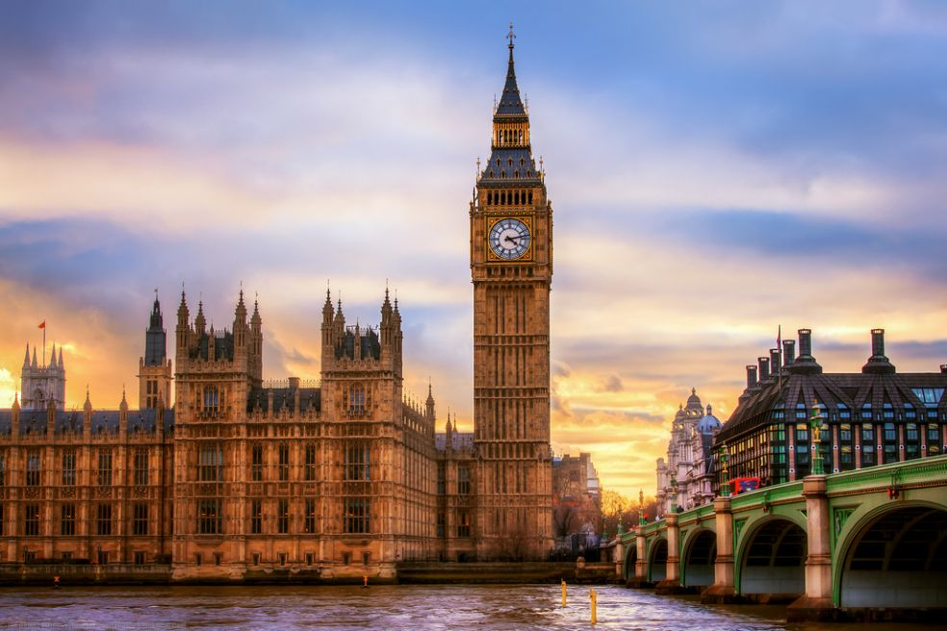
Buckingham Palace
Buckingham Palace has served as the official residence of the British monarchy since 1837. It is currently the monarch’s headquarters and the site of many royal events and ceremonies. According to the official royal family website, the State Rooms at Buckingham Palace are used for many official receptions hosted by the king, but are open to the public every summer. When visiting Buckingham Palace, Get Your Guide recommends watching the Changing of the Guard of the Royal Household Cavalry. The resource notes that the schedule of the changing of the guard may change, so on different days you can see foot or horse guards.
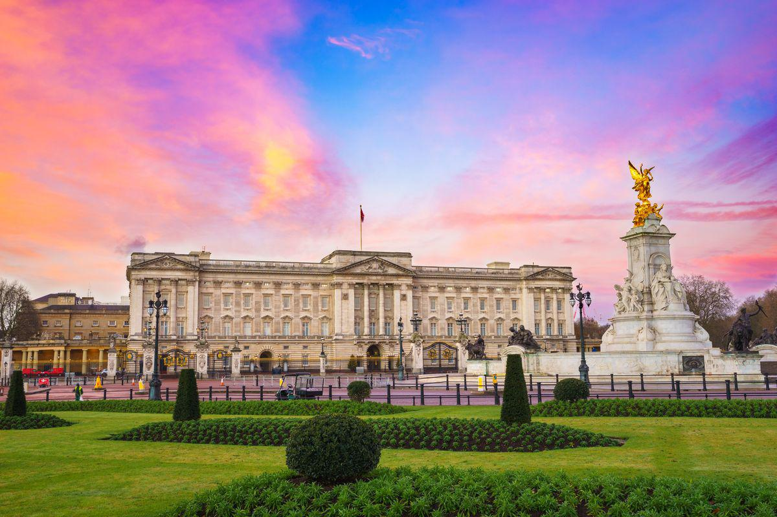
London Eye Ferris Wheel
What modern attractions in London should you visit? Take a ride on the famous London Eye Ferris wheel, located on the banks of the Thames in the Lambeth area. The height of the wheel is 135 m, which allows you to see almost all of London and its environs from a bird's eye view in clear weather. According to the official website of the attraction, the London Ferris wheel has received more than 85 awards for national and international tourism, outstanding architectural quality and engineering achievements. In fact, it has become the most popular paid attraction in the UK.
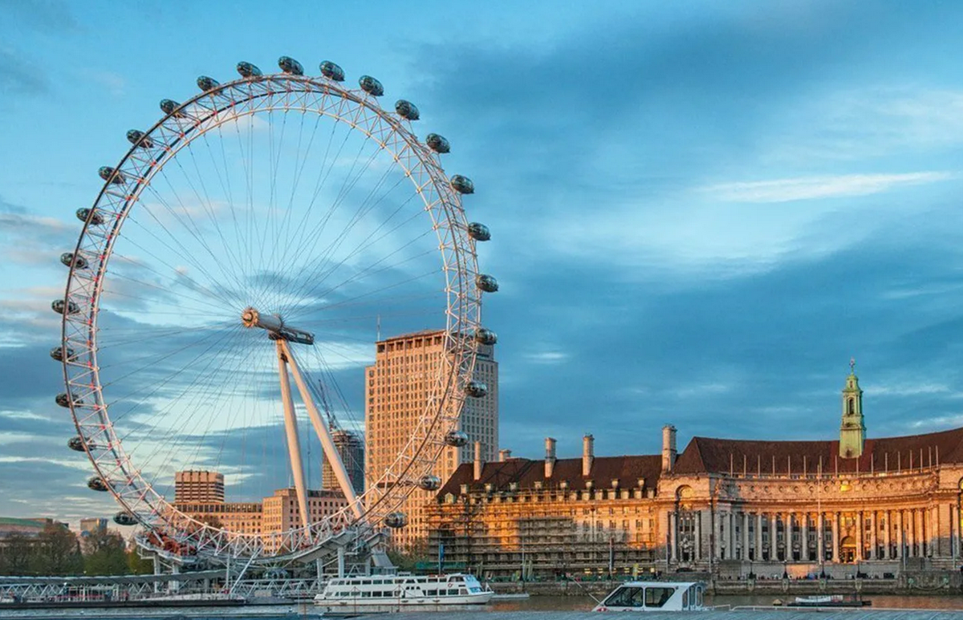
Tower
The Tower was founded by William I the Conqueror in 1078. During its existence, writes the resource Historic Royal Palaces, the Tower of London was a palace, a fortress, a mint, a repository of royal jewels and even a prison. The tower protected the royal estates and the royal family during wars and uprisings.
Currently, the Tower has become a carefully protected monument of architecture and history. On the territory of the ancient fortress there is a museum and an armory. The Tower is open to tourists. To do this, you need to buy an entrance ticket at the box office.
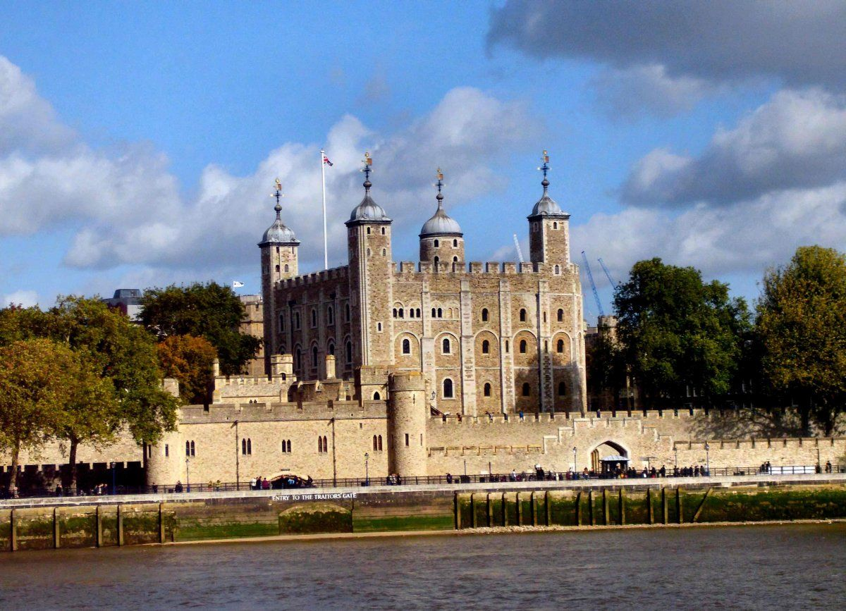
Tower Bridge
What river is London on? London is located on the Thames River. It is crossed by another famous landmark - Tower Bridge. The structure was opened in 1894, and the peculiarity of its design was that it is both a drawbridge (for the passage of ships along the Thames) and a suspension bridge (the upper span remains open for pedestrians). The 244 m long bridge is located between two towers in the Victorian Gothic style. The height of each is 65 m. The observation deck of the castle offers breathtaking views of the cityscapes of London.
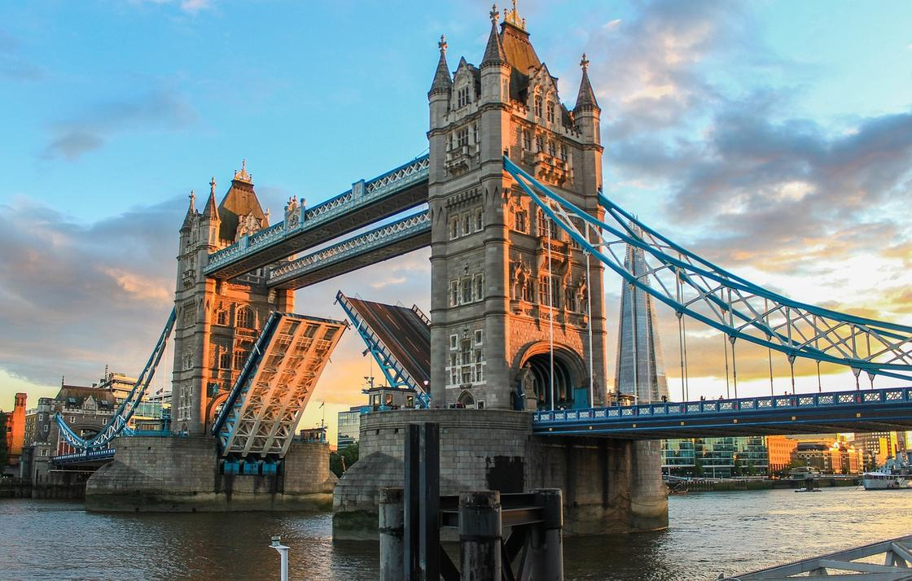
Westminster Abbey
«Let me show you London» resource writes that the abbey has a long and varied history and has functioned as an active religious site for almost 1,000 years. What began as a Benedictine monastery has become one of London's most popular attractions. The official name of Westminster Abbey is the Collegiate Church of St Peter at Westminster. Westminster Abbey is the coronation site of all English monarchs. Royal weddings and funerals take place here. Its grounds contain the burial places of some of Britain's most prominent figures.
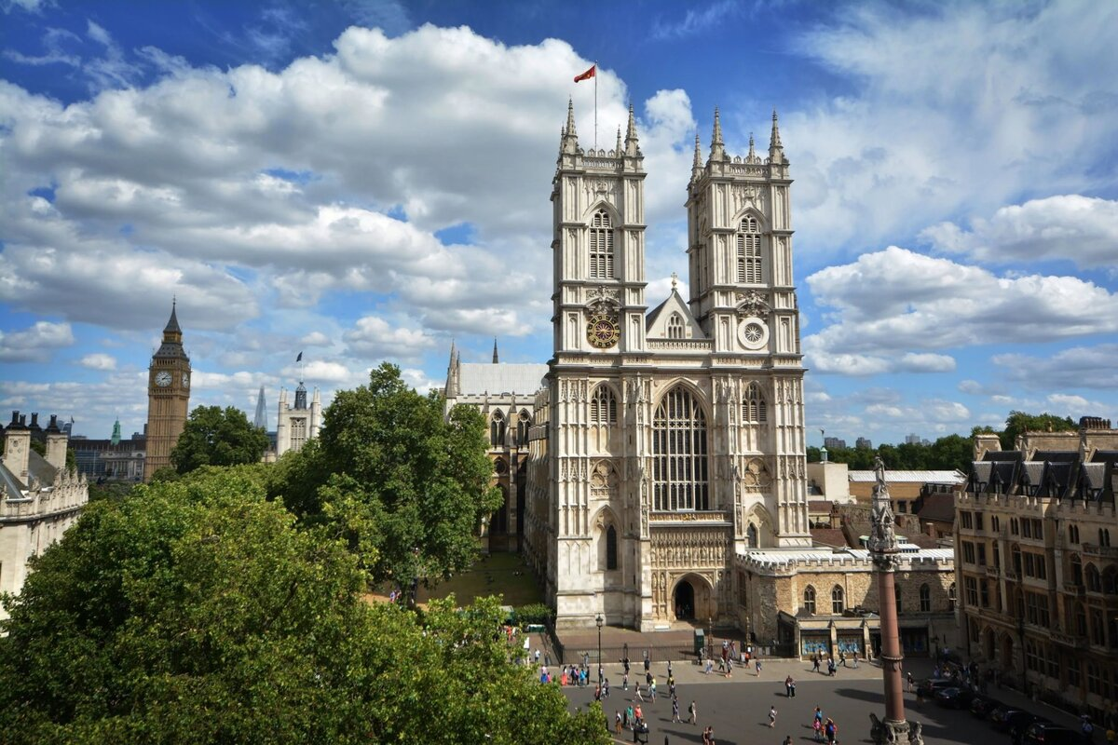
Piccadilly Circus and Street Piccadilly
It is one of the widest and busiest streets in the historic center of London. It runs from Piccadilly Circus to Hyde Park. The street got its name from the house of a seller of fashionable lace collars, called "piccadillies", who was located here. The owner of the house, Robert Baker, essentially became the person with whom the street and the square in west London began. There are several famous landmarks in the Piccadilly Circus area: the sculpture of Eros, the Criterion Theatre, and the London Trocadero. The main attraction of Piccadilly Circus is the building of the Royal Academy of Arts.
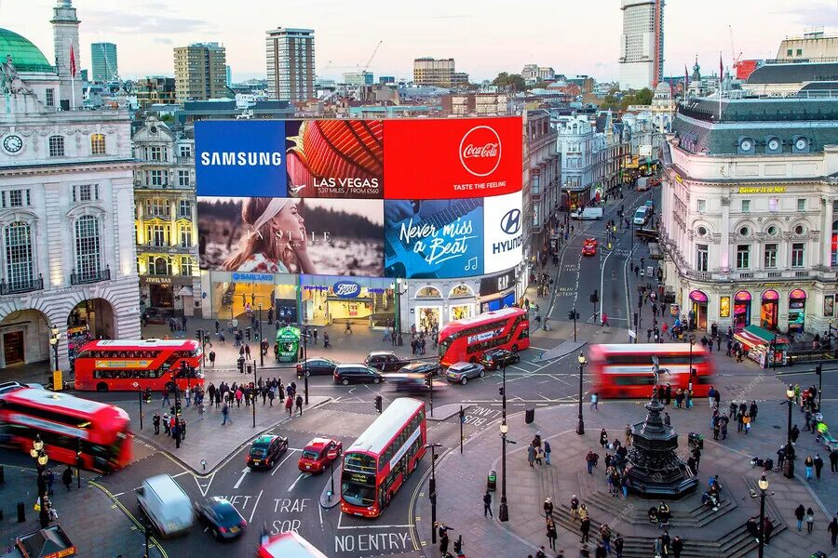
Hyde Park
Hyde Park is popular with both tourists and locals. Its history began in the 16th century, when Henry VIII turned the land purchased from Westminster Abbey into a place for royal hunting. A century later, Charles I ordered the improvement and reconstruction of Hyde Park. The park is picturesque, with the Serpentine Lake on its territory. To the west of Hyde Park are Kensington Gardens, a royal park around Kensington Palace. Hyde Park is home to Speaker's Corner, where anyone can give a speech.
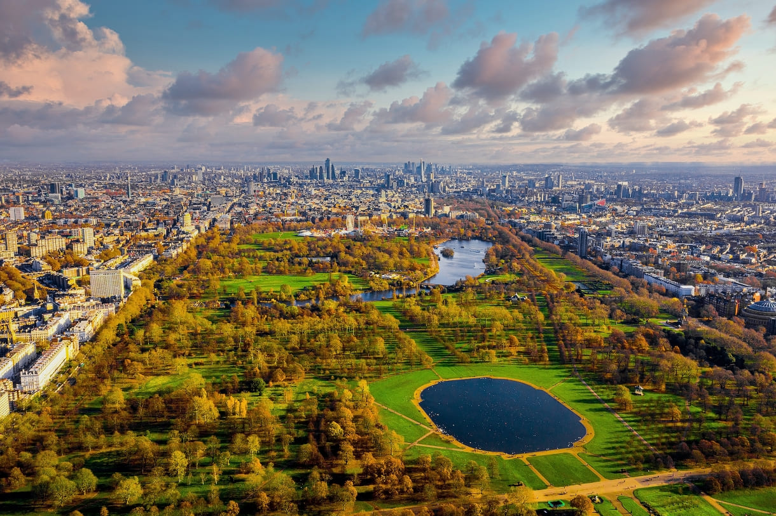
Trafalgar Square
Trafalgar Square appeared in London at the beginning of the 19th century. In the center of the square, a statue of Admiral Nelson stands on a column of dark gray granite. The pedestal is decorated with four panels cast from captured French cannons, depicting Nelson's four victories. Every year on Christmas Eve, a Christmas tree is installed in Trafalgar Square. According to London City Break, it is given to London by Norway as a gift every year as a token of gratitude for the support of Great Britain during World War II. This tradition has been going on since 1947.
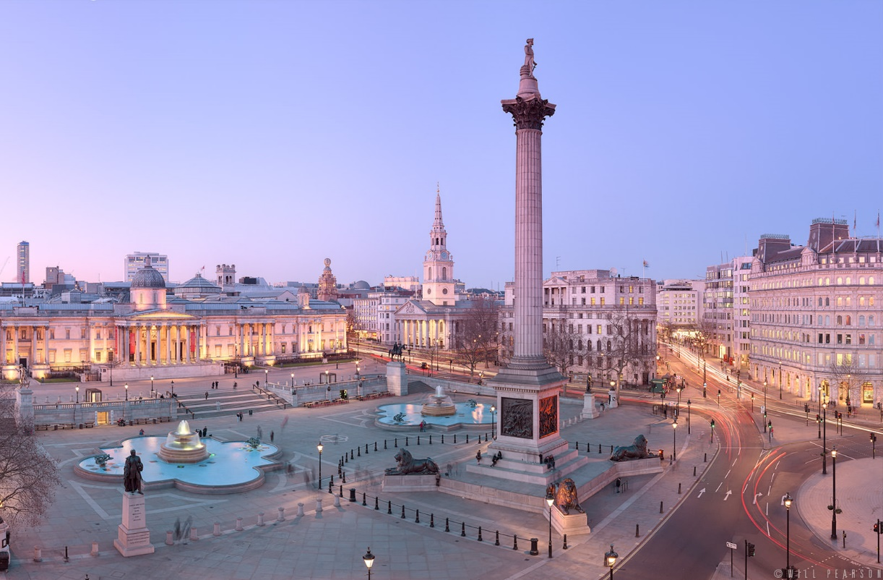
Covent Garden
Today, Covent Garden is a vibrant and distinctive area of ​​London. In the Middle Ages, the site of the modern district was the site of Westminster Abbey, where a garden was laid out, which gave the district its name. Tourists and locals alike come to Covent Garden to stroll the streets, sit in cafes, listen to classical music, and watch professional artists perform on Covent Garden Piazza. The facade of the Theatre Royal in Covent Garden: Wikimedia/Russ London Covent Garden is home to the Royal Opera House, the home of the Royal Opera and the Royal Ballet. The current building is the third to stand on this site. The theatre was built in 1858 and underwent a major renovation in the 1990s. 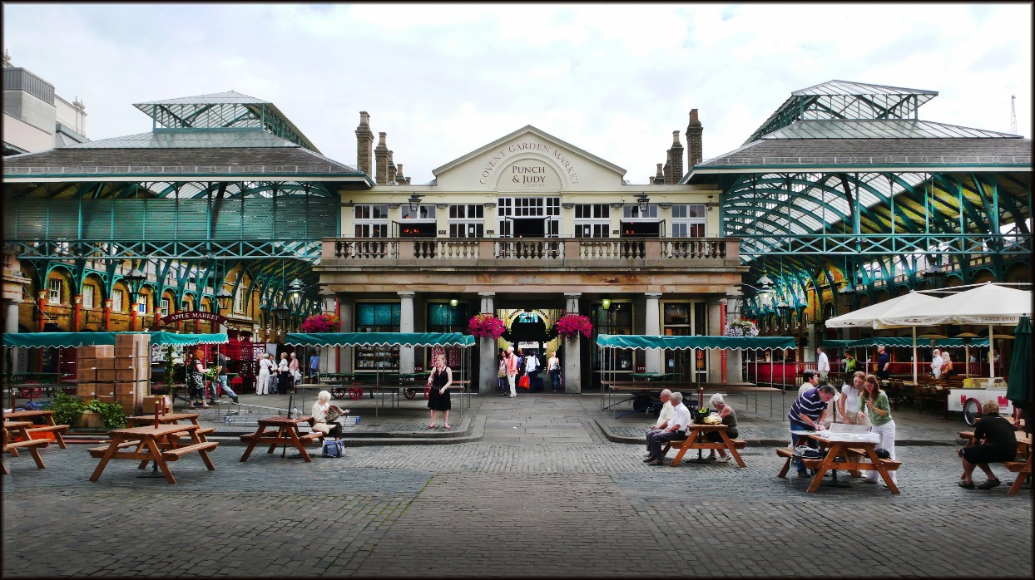
London will certainly be remembered by travellers for the changing of the guard of the Royal Guards, the chimes of Big Ben, and the incredible views from the London Eye. The British capital has much to show and tell travelers who want to learn about its history and culture.

Список литературы
- https://www.nur.kz/leisure/tourist-routes/1722804-london-dostoprimecatelnosti-top-10/Еженедельник «Аргументы и факты» подшивка 2016 год
2. https://yandex.ru/images/

